Oregon Inspections iOS App

There are three ways to perform a search:
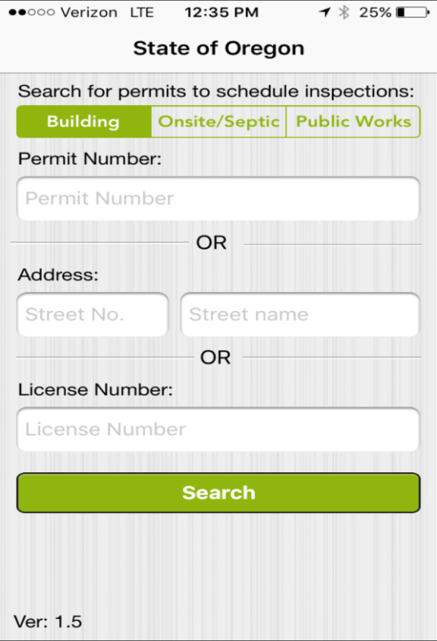
Records with the following statuses are not returned:

Withdrawn
Void
Closed
Finaled
Expired
The Building Module is the default search you will need to select Onsite/Septic or Public Works permits on the search screen to change your search module.
Just like the search in ACA you can enter part of the permit number to run your search.

You can also use ‘%’ as a wild card to search for partial information. For example if searching for 123 Applegate you can enter 123 in the street number and appl% in the street name to find the address.

Records are returned based on the search criteria:

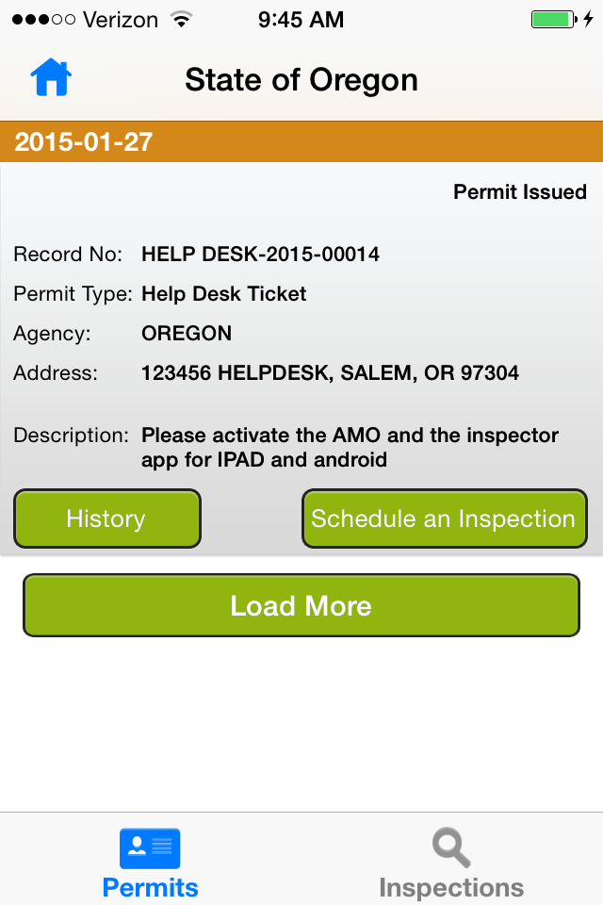
“Schedule an Inspection” button is available when:

Status is either…
Permit Issued
Permit Issued/Under Insp
TCO Issued/Under Insp
TCO Requested/Under Insp

ASI checkbox “Allow Inspections Prior to Permit Issuance” is checked.

“History” button is always available. It displays inspection result history on the record. User will get an alert if no result history exists.

Schedule an inspection:
Search for the record. Tap “Schedule an Inspection” button. Inspections will display based on the agency’s Pending inspections set up.
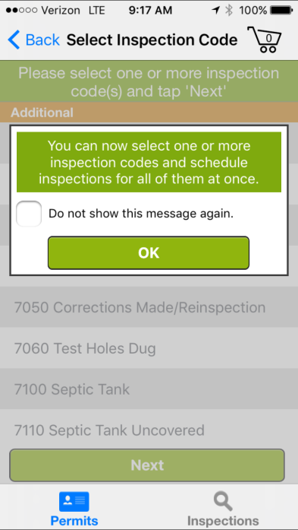
You will get the following message each time you go to schedule an inspection unless you check the box next to “Do not show this message again.” Prior to selecting the “OK” button.

Open Scheduling Agency – Inspections that are “Pending” on the record will show under “Required” and the remaining inspections in the inspection group are listed under “Additional.”
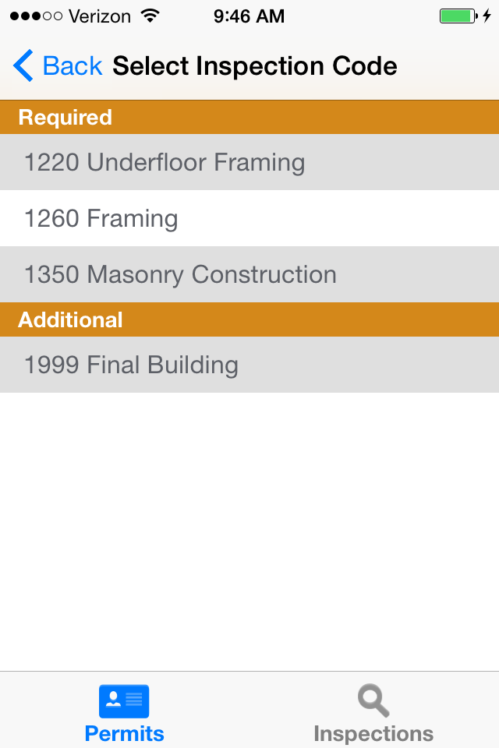

Pending Agency – Inspections that are “Pending” on the record will show under “Required.” No other inspections are available for the customer to schedule.

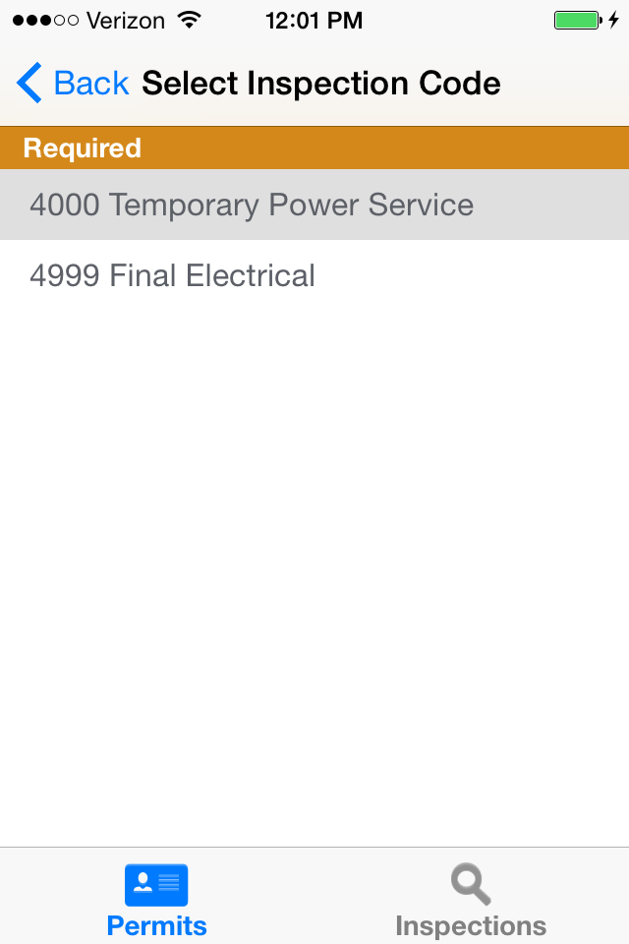
After user selects the appropriate inspection, a calendar will display, based on the agency’s inspection calendar set up in V360 Admin.
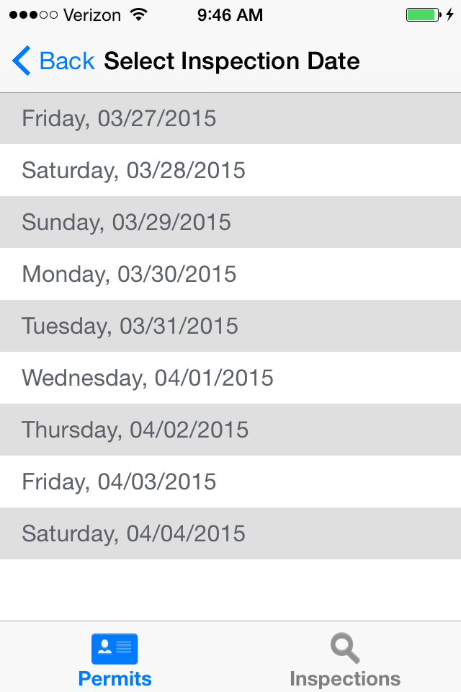

After date is selected, Contact Name and Phone Number are required. Comments are optional. Click Submit to schedule the inspection.
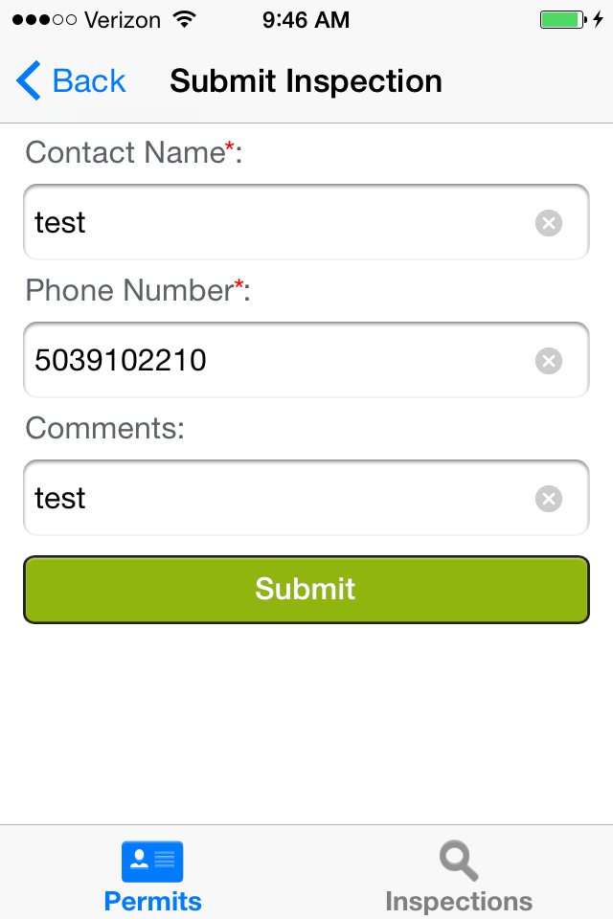

User gets a confirmation once the inspection is scheduled.
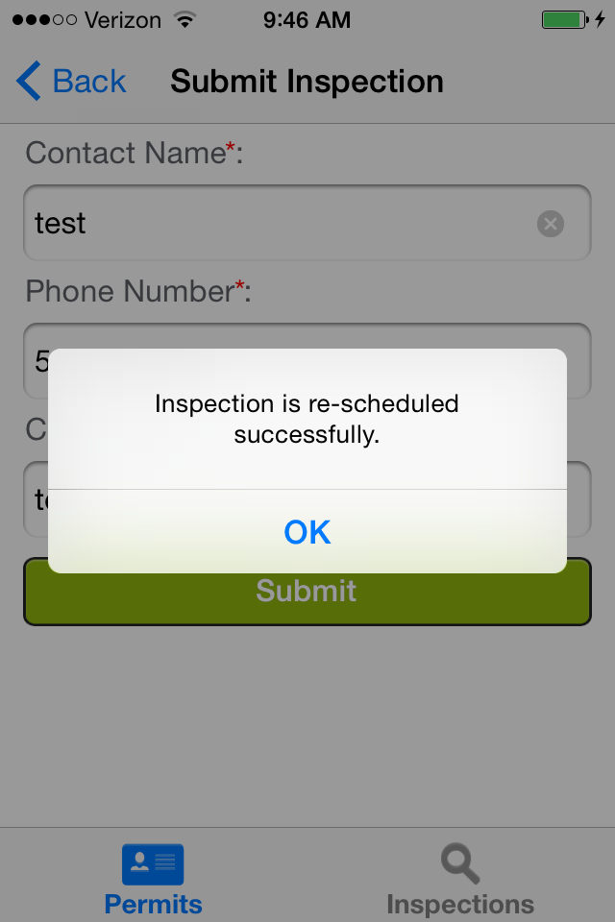

Note to Agencies: If your agency has elected to use auto-assign, Inspections will be auto-assigned based on parcel district and inspection discipline just like it works in ACA.

Reschedule or Cancel an inspection:
After searching for a record, the Inspections button (bottom right) will show existing inspections scheduled on the record. Use this to “Reschedule” or “Cancel” an existing inspection. The process to Reschedule is the same as Scheduling (listed above).

