## Overview

You can use the following methods to find records in Accela:

* Search for records from individual pages
* Search globally for records from the Launchpad
* Filter a list of records in a page with a Filter
* Return to a recently viewed record with the Launchpad Recent Records list
* Search for reference objects like Addresses, Parcels, Owners, Licensed Professionals or other Contacts from the Launchpad Reference Data Lookup buttons

## Searching from individual pages

You can search for records from any of the list pages that display records, as follows:

1. Navigate to a page that contains a list (such as Records or Inspections).

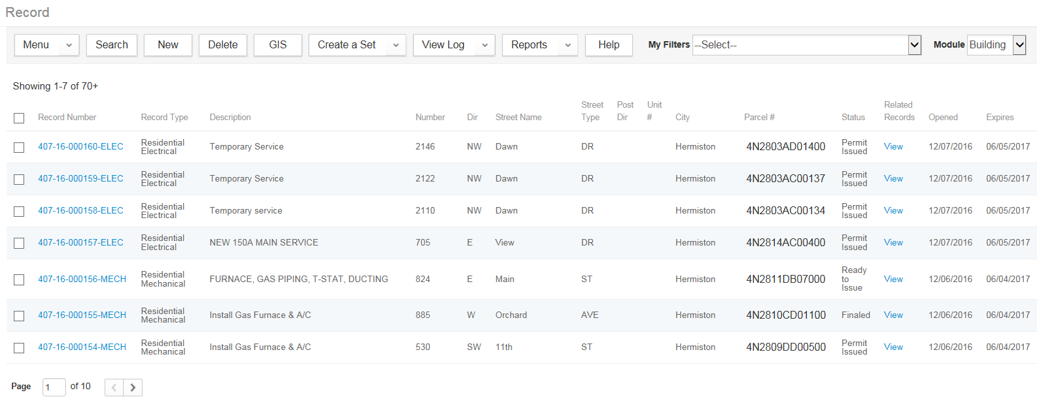

1. Click Search.

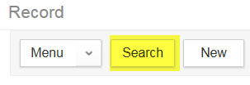

1. Type your search criteria into the form.

notes_final25You can use the % wildcard symbol within text fields to generalize your search.

1. Click Submit.

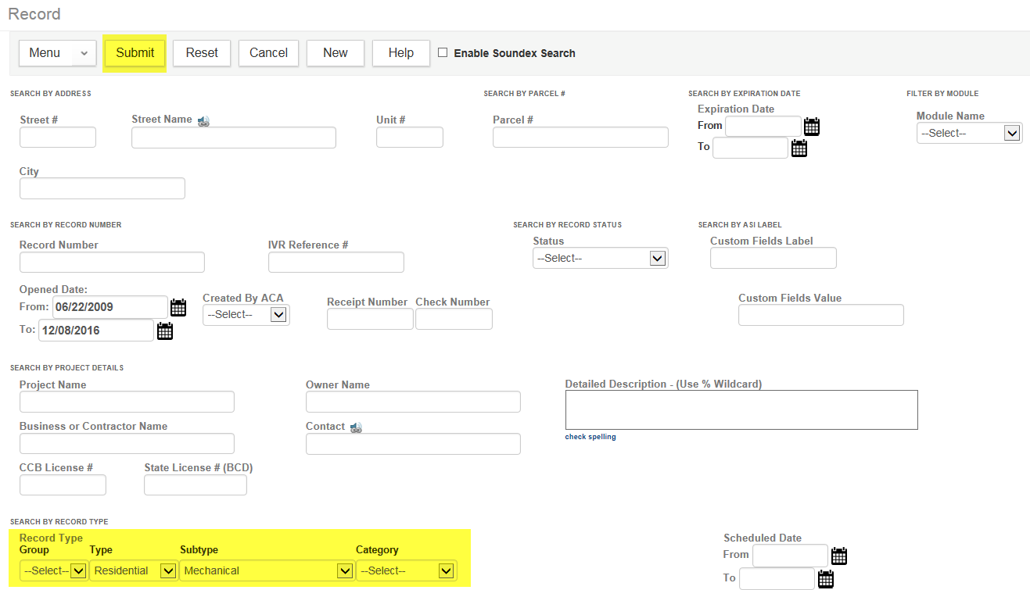

1. A list is returned that matches the search criteria:
2. If you need to refine the search results, click Refine Search.
3. Add any additional search criteria to the form.

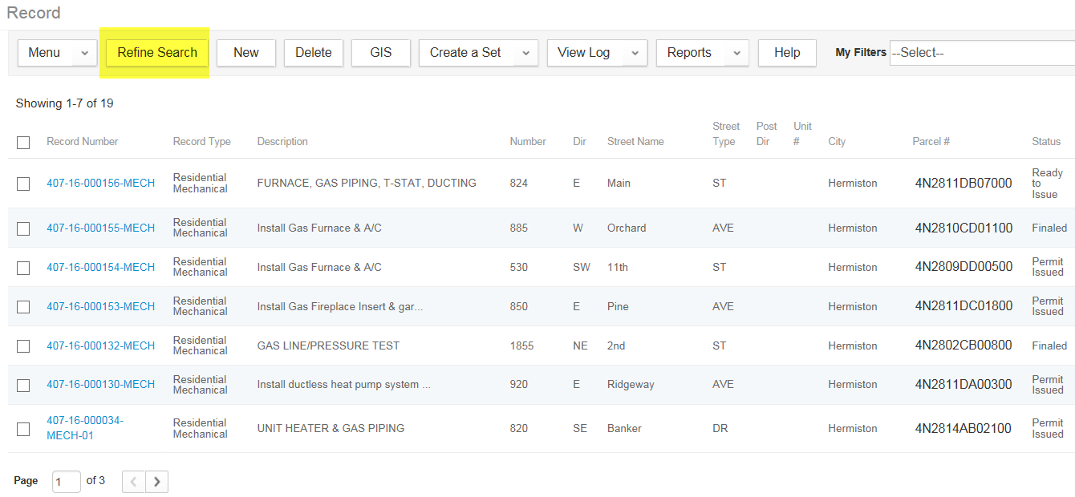

1. To clear your search criteria, we recommend selecting “Created in the Last 30 Days” from the My Filters dropdown.

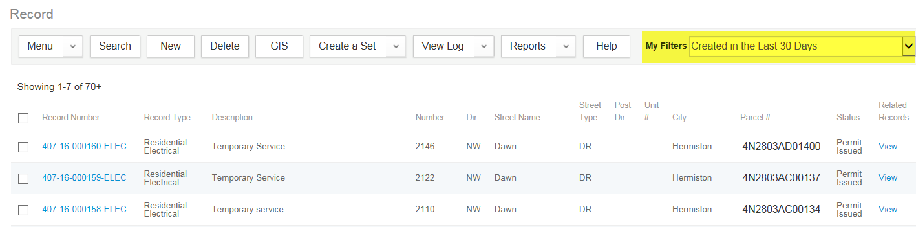

## 

## Performing a Global Search

Use the global search tool to find a record quickly.

1. Click the search button  in the main menu.

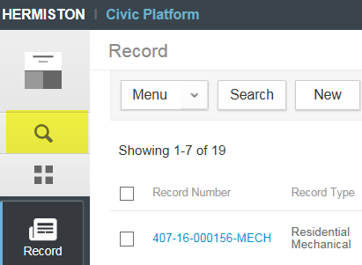

1. Enter search criteria. For example, we are looking for records related to someone with “dawn” in their name.

Your keywords must include a minimum of three characters of any type. The searches are not case sensitive. You cannot search across agencies or use the % wildcard symbol to specify a global search.

1. Click Search.

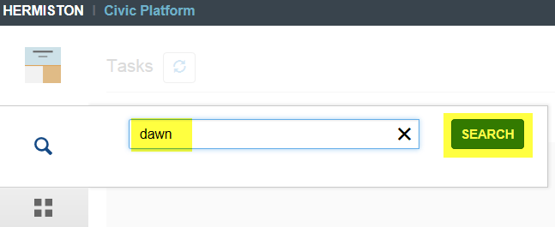

Any Records, Locations, Contacts, or Parcels with associated data that matches your search terms are returned in a list and are grouped by type. Clicking on each of the type tabs at the top will allow the user to navigate to the various Locations, Contacts, or Records that match.

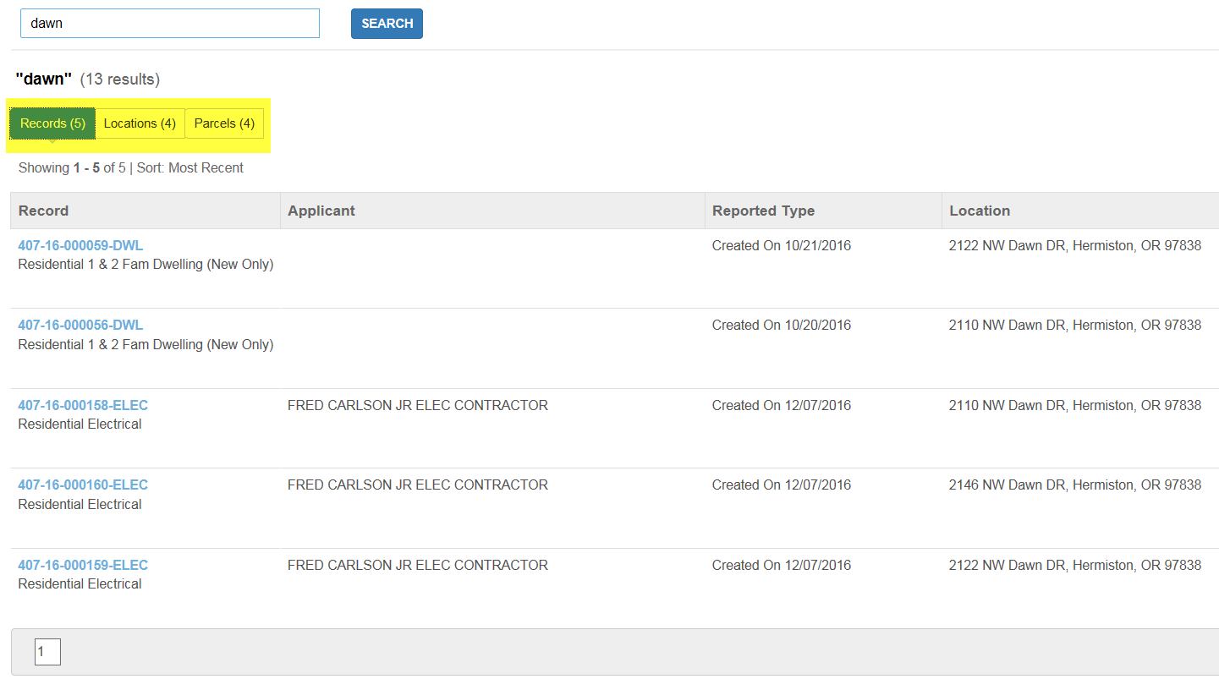

*notes_final25Search results are persistent for the duration of a user’s work session. If a user navigates to another space (for example, to click a record link to view that record), clicking the search button will allow the user to return to the search results for the last search performed. New search criteria can be entered at any time.*

## Using Filters

To filter the records in a list page:

1. From a list page, open the My Searches menu.

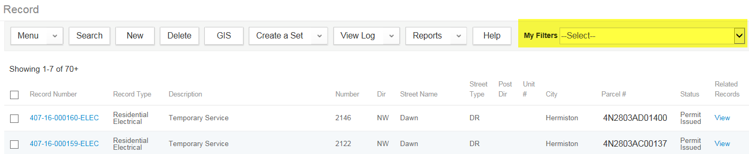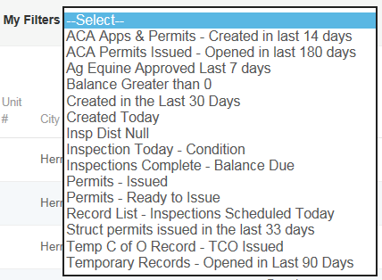

1. Select the desired filter.

The records that match the selected search appear in the returned list.

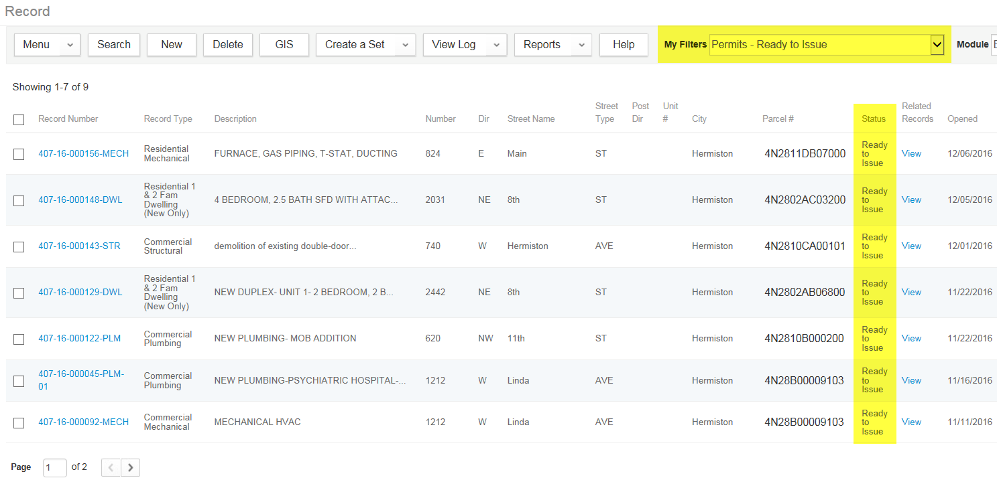

## Using the Launchpad Recent Records List

The Launchpad provides a list of recently visited applications and records, including reference items (address, owner, parcel, licensed professionals and other contacts). Each record displays in the order of when they were last accessed, most recent first. To return to a recently viewed record:

1. Click the **Launchpad** button.



1. Choose a record under the **Recent** header.

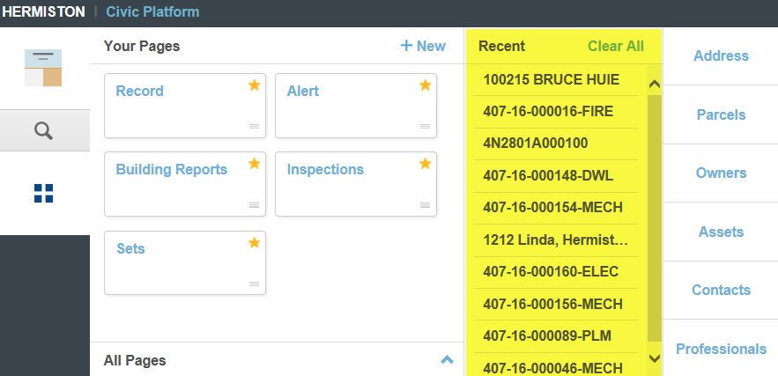

Selecting a record from this list will open it in a new space that can be pinned to the Main Menu:

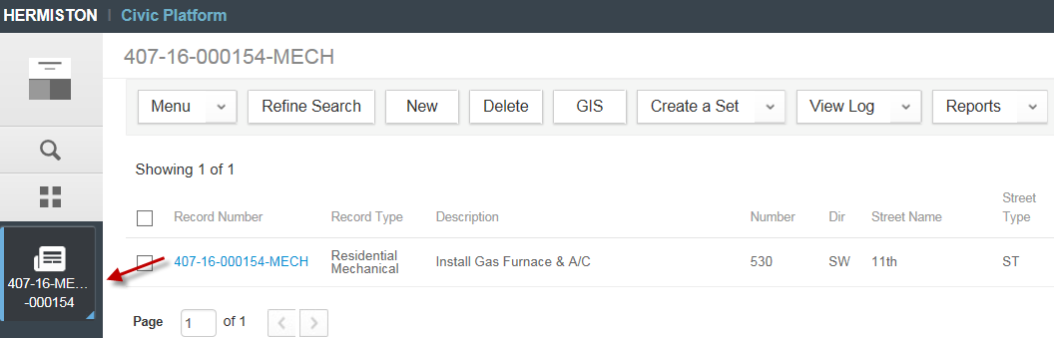

To clear all of the records listed on the Recent Records list, you can click Clear All. This action cannot be reversed.

## Reference Data Lookup from the Launchpad

Reference data is data that is stored in the database as an individual data entity, rather than as part of a transactional record. Reference data can then be pulled from the database and used in multiple transactional records.

Example: A reference address is entered into the database. A user within the agency can create a new building permit application for the address entered into the reference data. That user can look up the address in the reference database and retrieve the complete address from the database, while establishing a link with that address record. At any point in the future, a user can open the reference address record and from that record, access/view all applications and records for that address, associated through that link.

To look up a reference object:

1. Click the **Launchpad** button.



1. Select the desired reference data links from the right-hand side of the Launchpad.

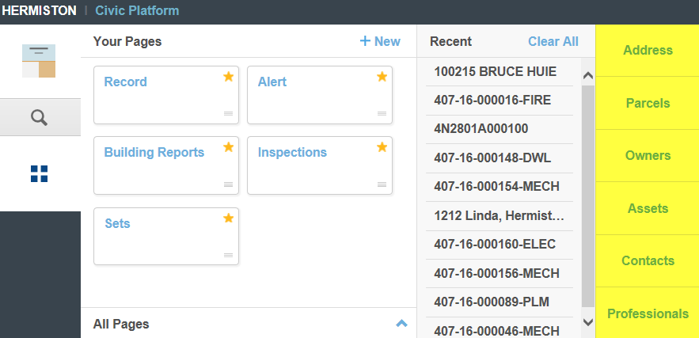

1. Enter search criteria and press **Enter** (or click **Submit**).

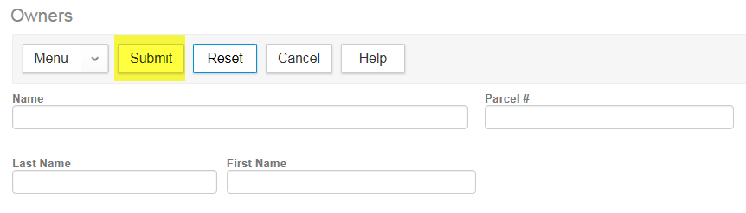

Any records that match the search criteria will be returned. Clicking on the Name (in blue) opens up additional information about the record.

