How to Correct Adobe Read Error in Document Preview Back Office

Some users may receive this error message when trying to “Preview” a PDF document in the Documents Page in the back office:
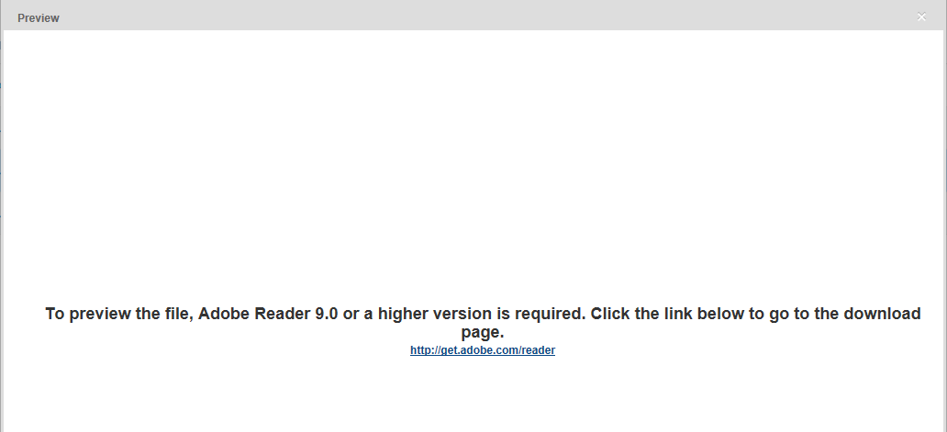

To correct this, do the following:

- Make sure that the latest version of Adobe Reader is installed on the computer.

- Next, go to the Tools icon in the upper right corner of Internet Explorer > click Manage add-ons:
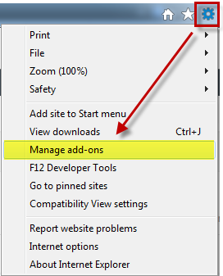

- Select Toolbars and Extensions > make sure All add-ons is selected > select Adobe PDF Reader > click Enable to enable the Adobe Reader add-on in Internet Explorer. Close the windows and try again.
