Adding a User Account to Communication Manager

As part of Communication Manager, we must configure an email account for each user (this is not their actual email account) so that when ad hoc emails are sent, the recipient will know who sent it. When adding new users to the system, in addition to the regular setup for a new user, you will need to also configure Communication Manager

V360 Admin > Communication > Account Settings

- Click the New button
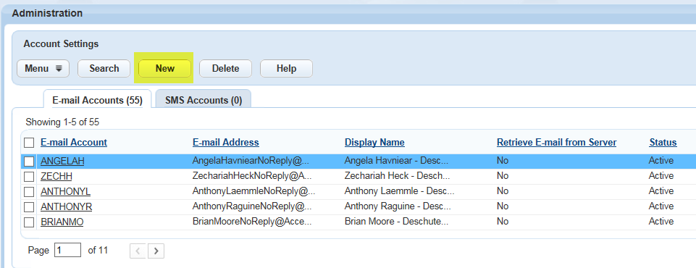

- Complete E-mail Account as the USERNAME; the E-mail Address should be FirstnameLastnameNoReply@Accela.com; Display Name should be Firstname Lastname – Agency. See example below.
- Click Submit
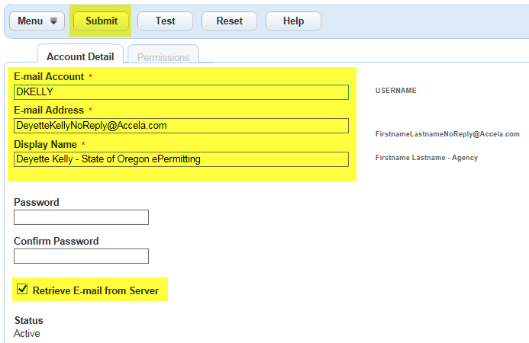

- Click the Permissions Tab
- Click the Assign User button
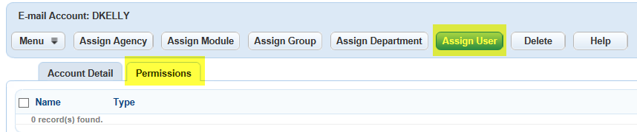

- Under User expand the module tab (if they have permissions in multiple modules you can just pick one that you know they have higher than read only permissions)
- Expand the module to see the user groups
- Expand the user group to see the user names
- Place a check mark in the box to the right of their name
- Click the Submit button – You should receive a message that ‘1 user(s) added successfully.’
