CONDITIONS OF APPROVAL

- With your record selected, click on the Conditions of Approval page
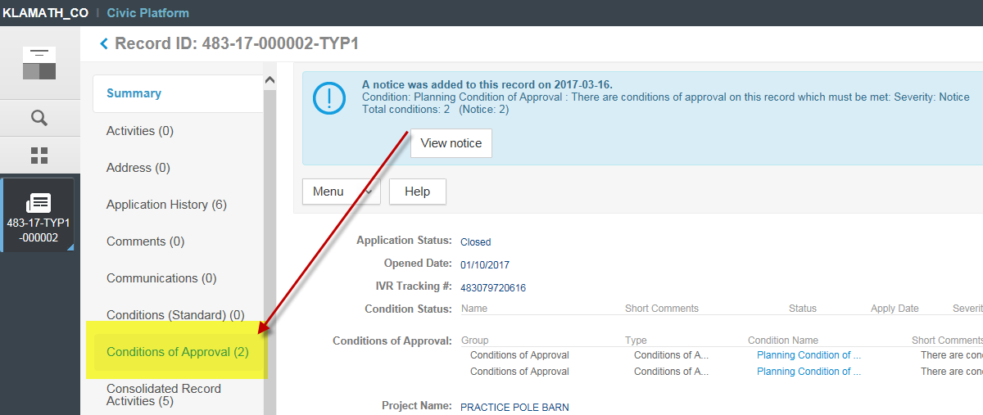

- Click the New button
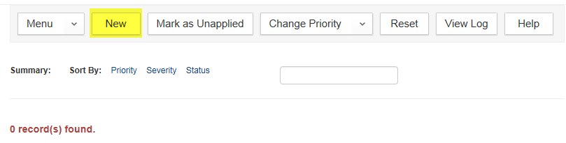

- Select “Conditions of Approval” from the dropdown
- Click the Submit button
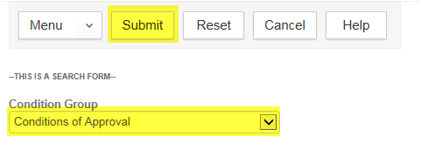

- Check the box in front of the appropriate Condition of Approval
- Click the Select button
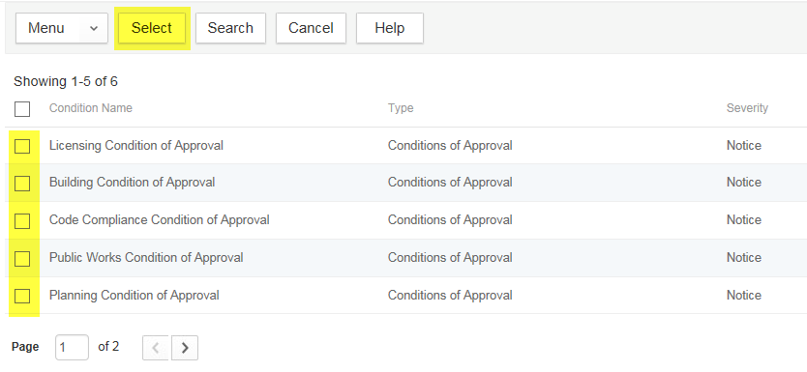

- The Condition of Approval has now been added with a default comment: “There are conditions of approval on this record which must be met”
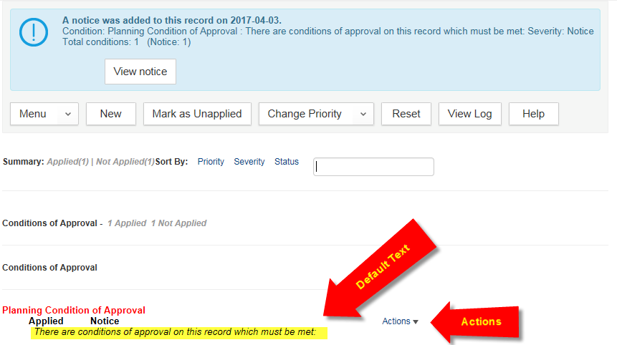

- To add additional detail, click on the Actions dropdown
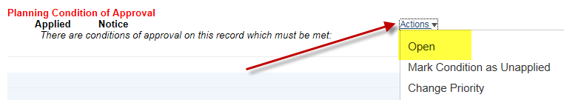
- A new window will pop up where you may input additional information. There is a basic HTML editor included, which will allow you to format your text
  - NOTE: You have access to any Standard Comments loaded into your agency as well
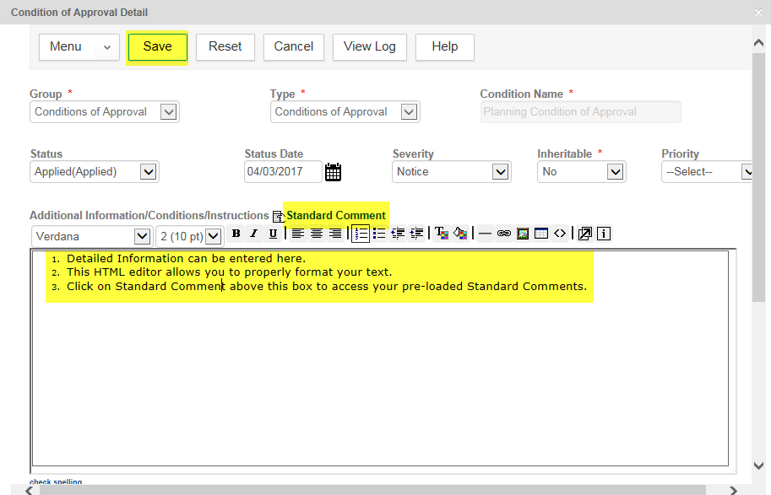

- To update the default text that appears in the Conditions of Approval list for the record (see #7 above), scroll down and change the Short Comments (this step is optional)
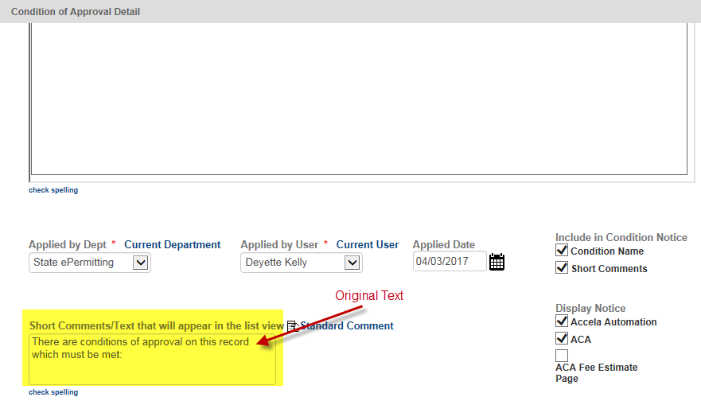

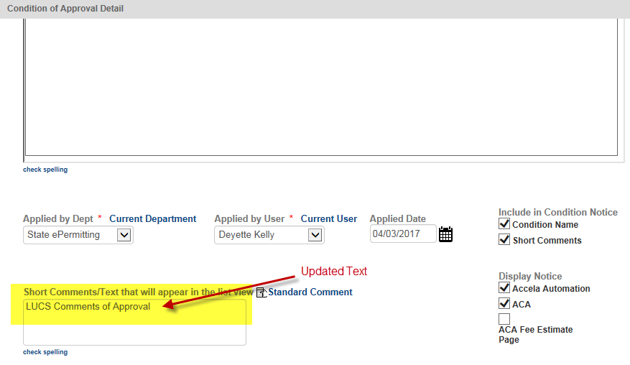

- After updating with the necessary information, click the Save button

- You can now see the updated short comments in the list
