Click Manage Inspections
Click Schedule Inspections
Select the inspection you want to schedule
Then on the scheduling screen Click Add. Leave the Schedule Date alone it will be refreshed.
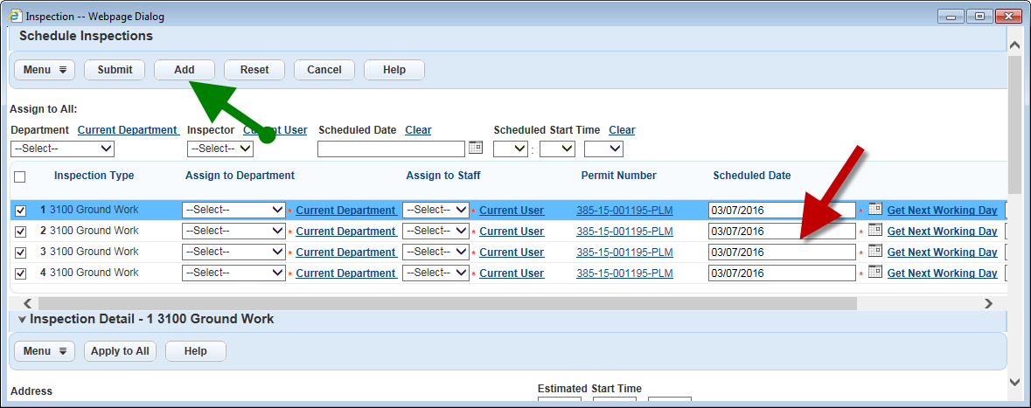
Select the inspection you want to schedule
Repeat these two steps till you have the amount of inspections you want. They will all show below.
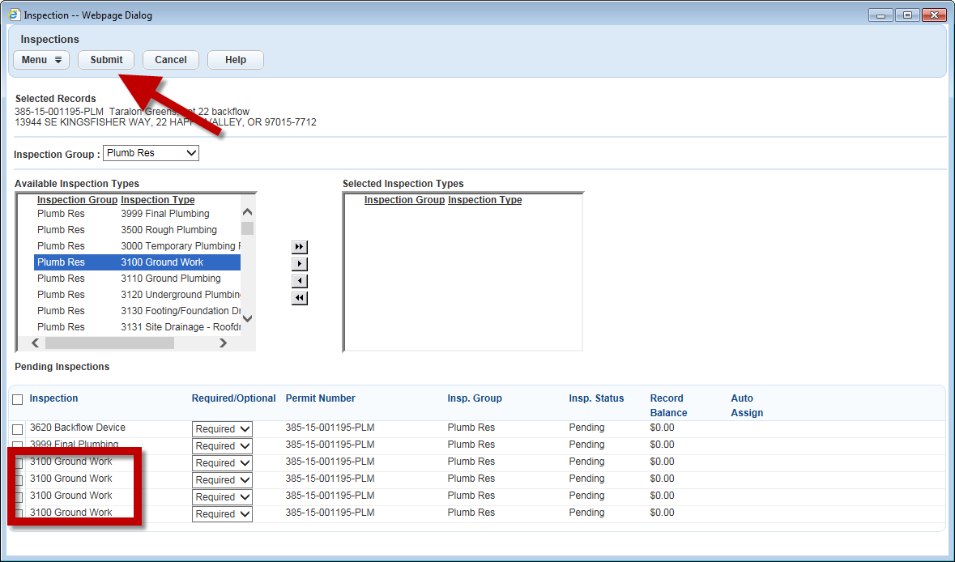
Now that you have the right amount of inspections you can change the schedule dates to the dates you want
Then Submit
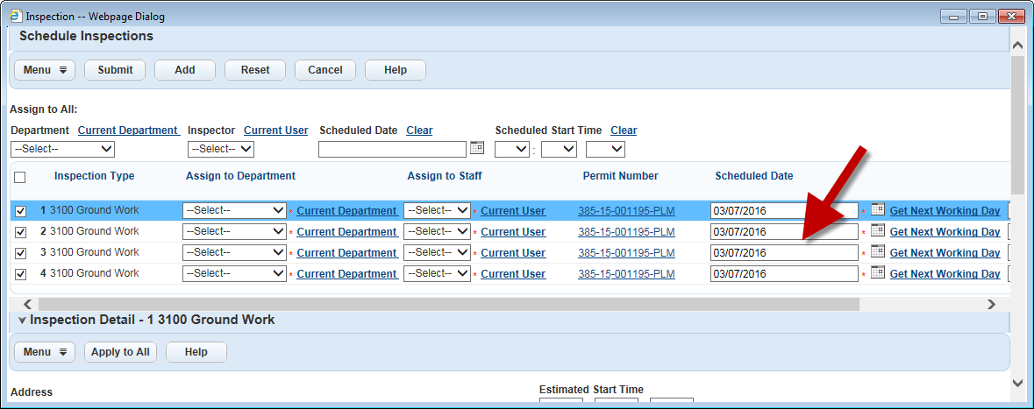
The inspections will be scheduled for the different days
