Fund Transfers

Introduction
Funds taken in on one record can be transferred to another record using the Fund Transfer feature. The funds on the original record will be refunded once the process is complete.

Processing a fund transfer
In this example, the wrong record type was initialized by mistake and fees were assessed and paid for on Commercial Structural (995-19-000084-STR).
The correct record type was then initialized and fees assessed and invoiced ready to be paid on Residential Structural (995-19-000085-STR).

First, the fees on the original record (995-19-000084-STR) need to be Voided to cause an Amount Not Applied.
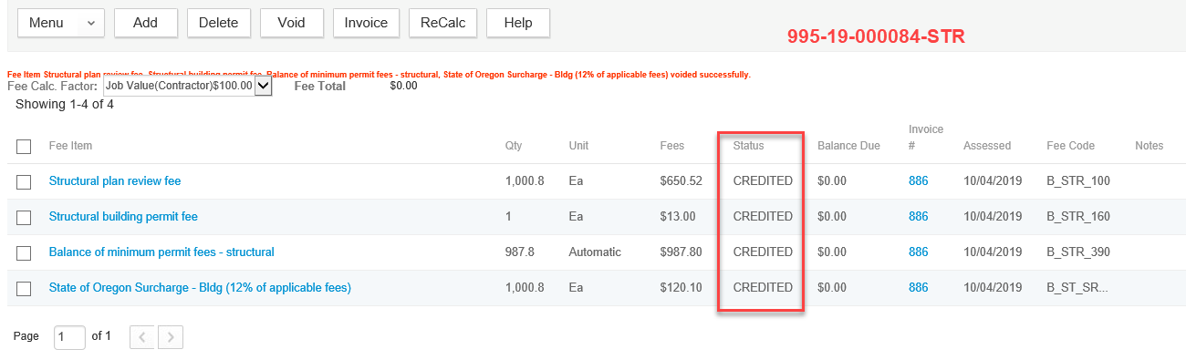

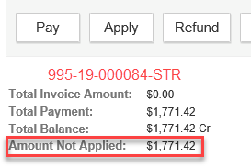
Next, search for the new and correct record (995-19-000085-STR). The fees should be invoiced and ready for payment.
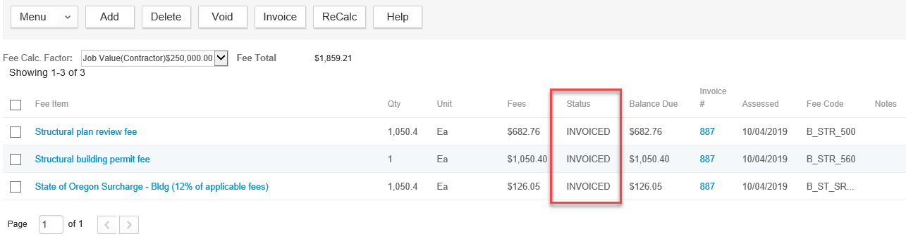

Go to the Payment portlet and click Fund Transfer.
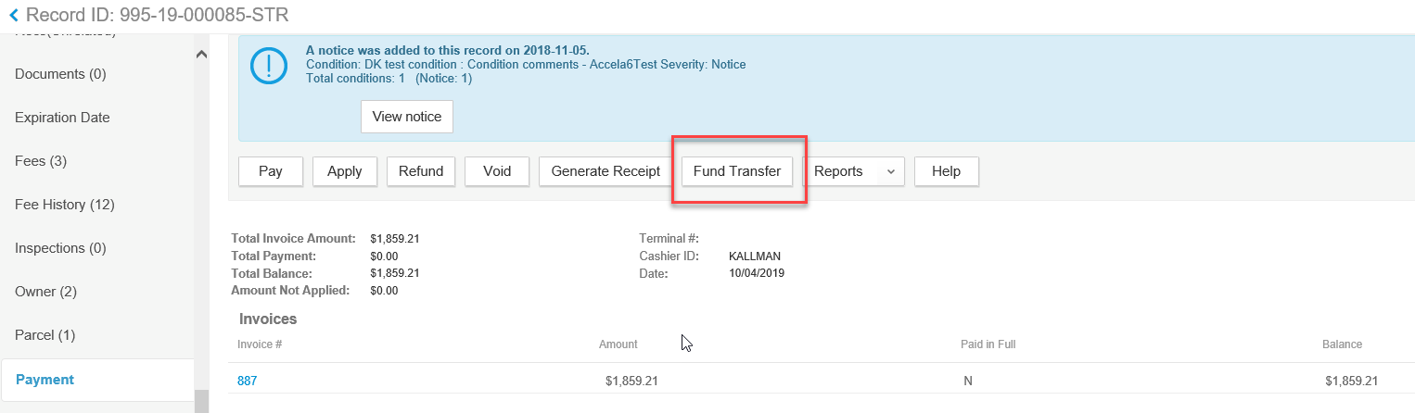

User will be prompted to search for the record you need to move the money from, use the record number search field and search for the record with the Amount Not Applied (995-19-000084-STR).
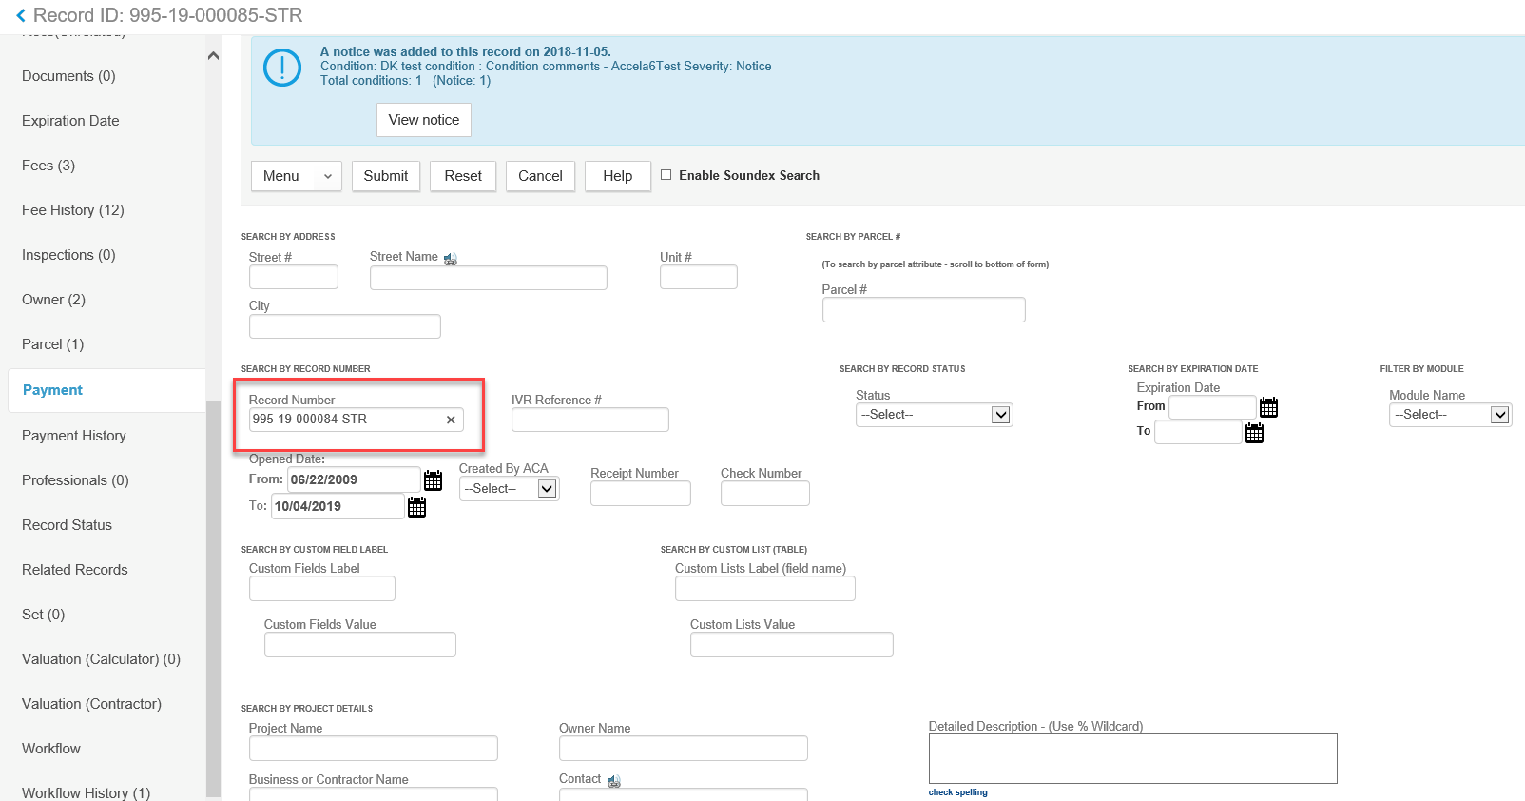

Place a check next to the appropriate record and click Select.
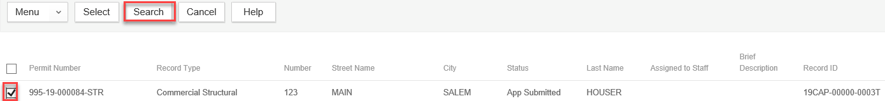

If the record selected does not have an Amount Not Applied available, the user will receive the following message and must perform the search again.
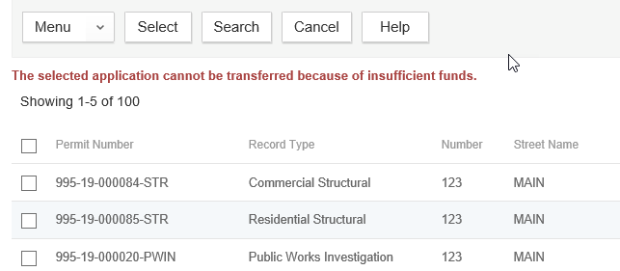

If a record with an Amount Not Applied was selected, the user will see the following Fund Transfer detail screen.

Notice the Available Amount is the total Amount Not Applied.

Make sure to choose Fund Transfer as the payment method.

User must fill in the Transfer Amount. This must be the full Available Amount. Click Submit.
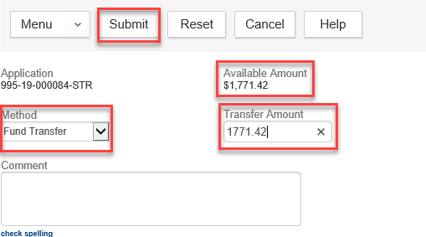

The user will get a message that the transfer was successful.

The funds have now been transferred to the new record as a Fund Transfer payment transaction, Fund Transfer payment method, and a status of Paid. Now the funds need to be allocated to the fees items.

Place a check next to the Fund Transfer payment transaction and click Apply.
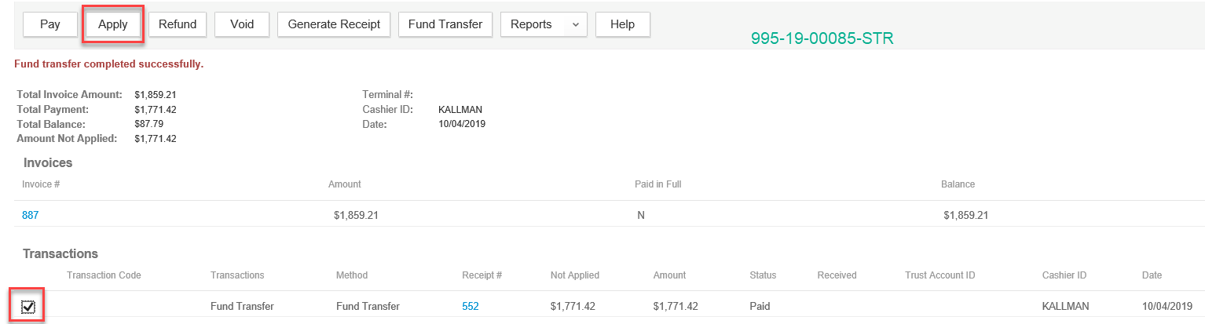 Select which fees to allocate the funds to and click Submit.
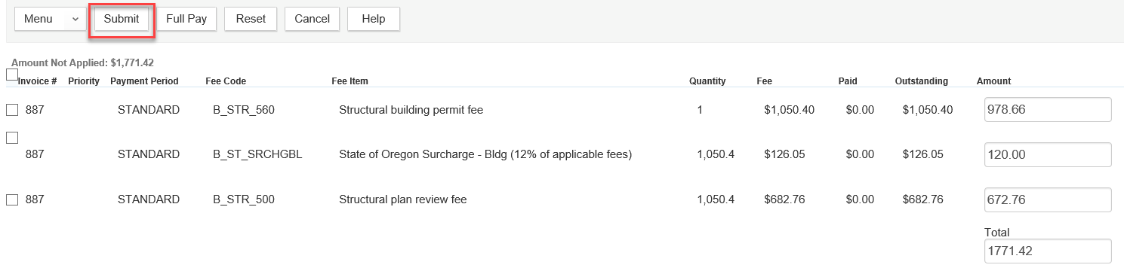
The new record (995-19-000085-STR) will now have a complete processed payment.
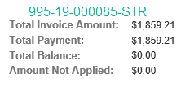
The original record (995-19-000084-STR) now has a Refund transaction processed with Fund Transfer payment method, and the Amount Not Applied = $0.00.
