Associating a Public User Account to a Back Office Licensed Professional, Owner, or Contact
The purchase of a permit and the uploading/downloading of documents in ePermitting requires a Professional License or an Associated Public User account. If a customer applies through ACA, then the Registered User (user that they logged in as when they applied) can download/upload documents that have been associated to their permit; they are automatically associated to a "Public User" for ACA use. However, when a permit is created in the back office, when you attach people to the record, they are not automatically associated to a Public User. This prevents them from being able to upload/download documents. In order to grant them access, you can manually associate them to their Public User (their registered ACA user), but only if they've previously registered for an ePermitting account.

Here is the step by step process of associating a public user account with a contact in the back office.

- The first step of this process is to get the Public User account information from the contact (in addition to their business, owner, or license info). If they do not have a Public User account, direct them to create one via the ePermitting website.
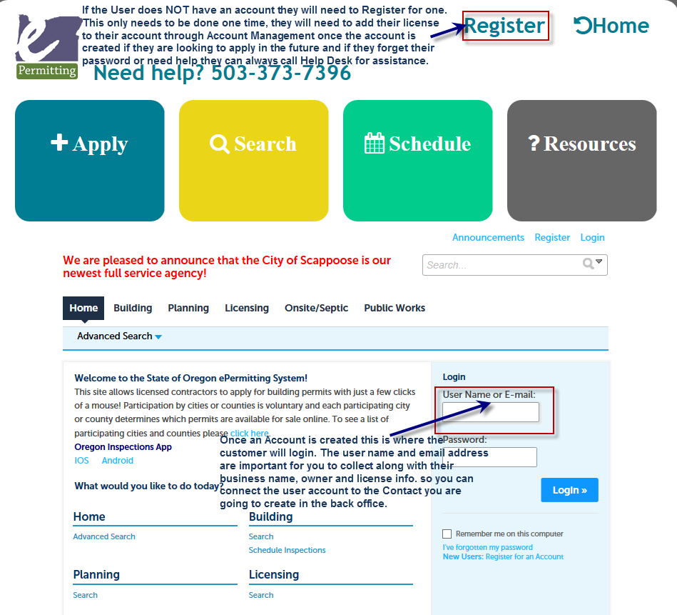

- Once you get their Public User information, in the Back Office go to the Launchpad and find the list of People pages.
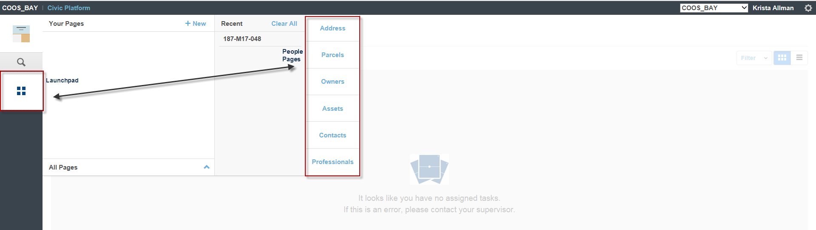

- Search for the Licensed Professional, Owner, or Contact and the results of your search will load. (You will be creating the Contact type that you want to add to the record and you want to be sure one is not already created.) 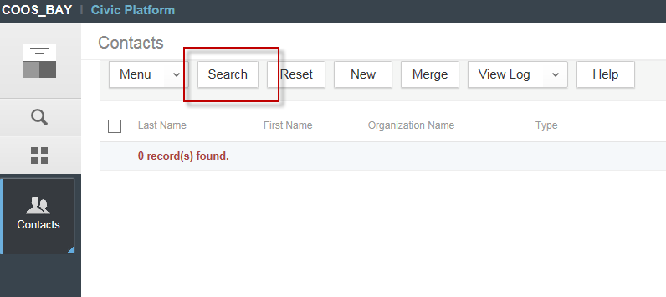 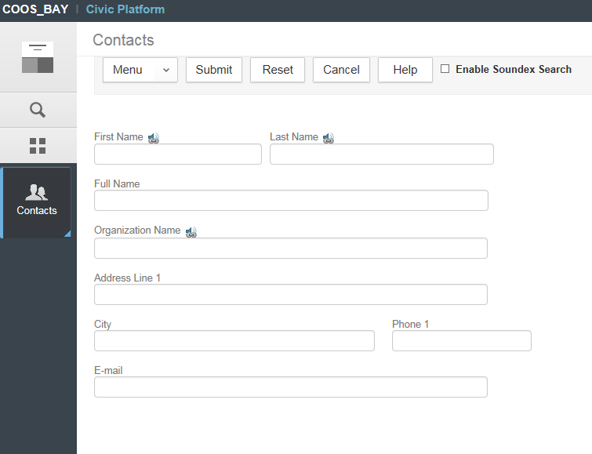

4A. If your search shows that no records are found Select the “New” button and fill in the information for your new Licensed Professional, Owner, or Contact. After you have all of the information entered hit the “Submit” button.
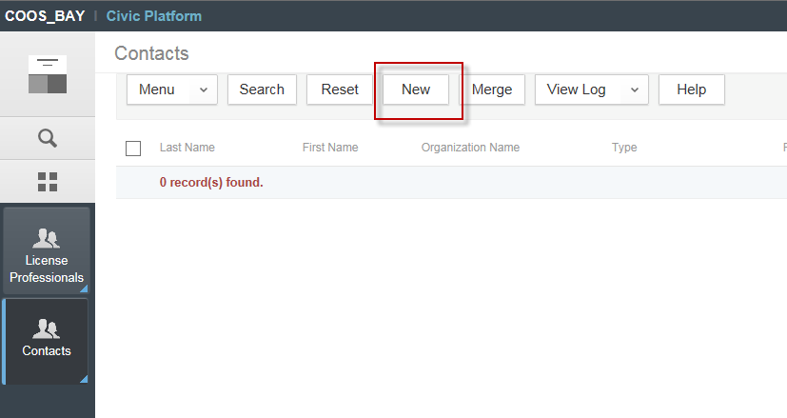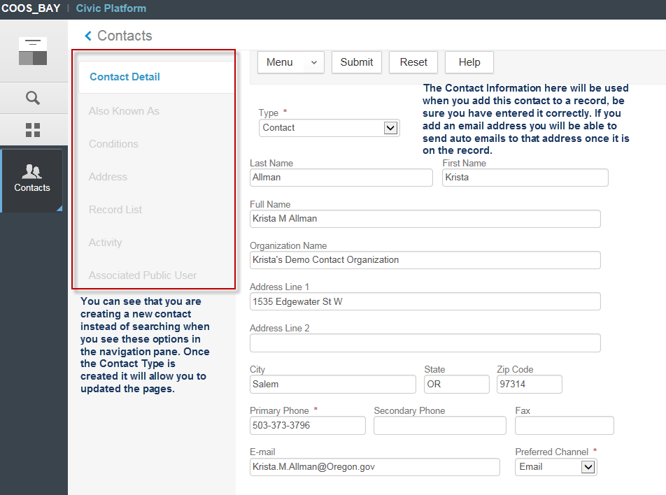

4B. If your search shows a match, select the correct result by clicking on the Last name (will be a blue hyperlink) and go to the Associated Public User tab in the Public User page.
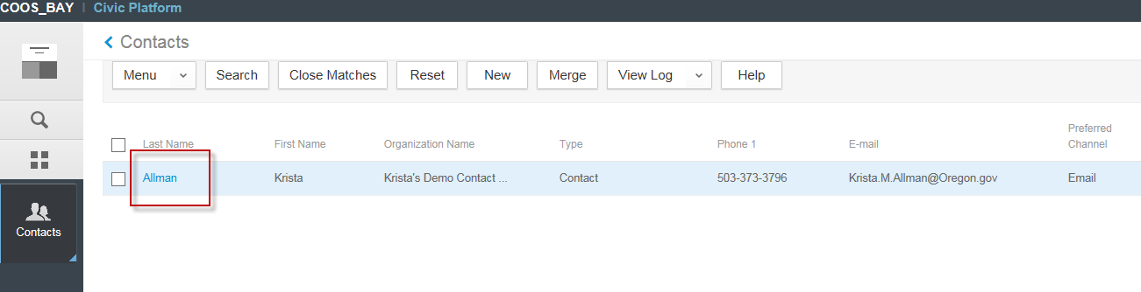

- Select “Associated Public User” from the navigation pane.
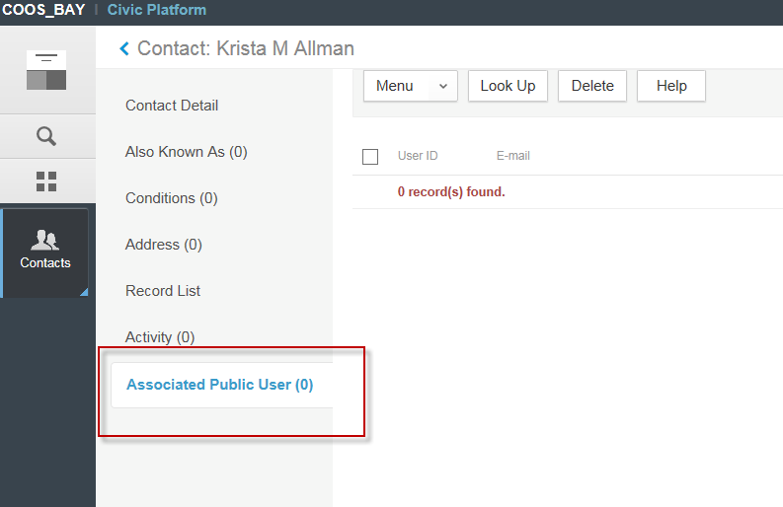

- Here you will use the Public User information that the contact provided you with and select the Look Up button to find their ACA (public user) Account. If you have difficulty finding the Public User account, you can try using a wildcard search. Accela uses the % sign. For example, if the username of the Public User was Nathan Flowers, you might try %flowers% in the Look Up in order to pull more results. Once you find the correct public user account, click the check box next to the correct public user account to select than click connect to add the contact to the account.
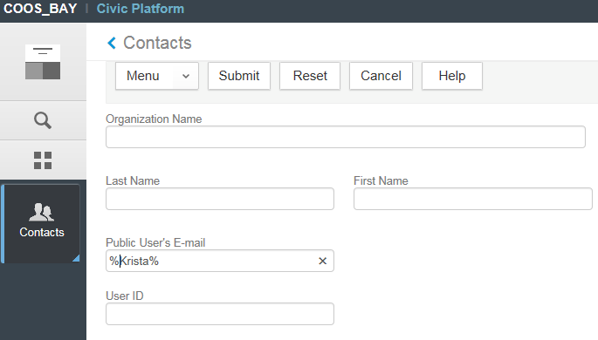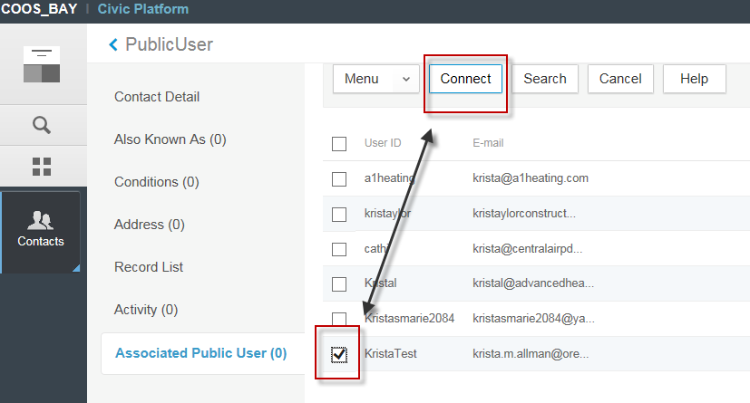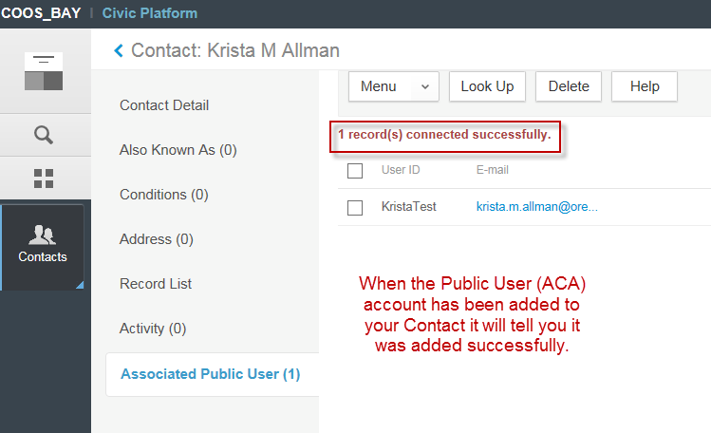

- Once the Associated Public User has been connected to the people reference record, next add that people record to the individual record (or delete and re-add it if it was already part of the transactional record and you have since made material updates). As the public user has been associated to the record, they will now be able to download/upload documents via ACA.
