Add Property Owner as Professional on Holding Tank Master Records

- Locate the appropriate Master record > navigate to Professionals.

- Select Owner (Property) as the license type > click Submit to search.
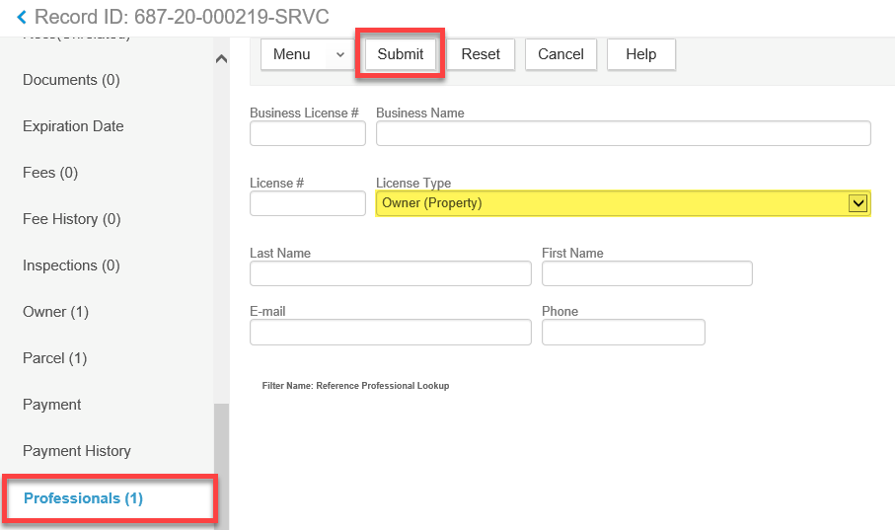

- Only one option will be available > check SEE PROPERTY OWNER INFORMATION > click Select.
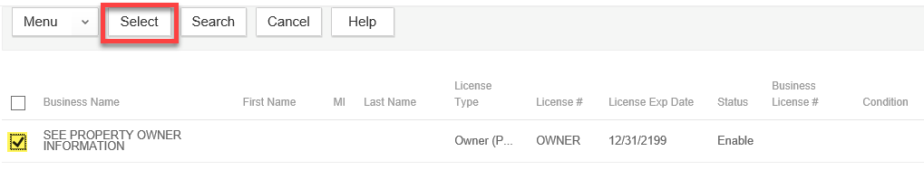

- You will have the opportunity to update this during the following year’s “renewal” period when annual pumping records are being recorded, if needed. Online users do not have access to update this information.

