Generate Follow-Up Letters for Property Owners

- From the Record List > select Record List Filter called Annual Service Master – Letters.

The filter uses the following criteria:
Status = Active (this will eliminate Master records that are Void, Withdrawn, In Enforcement, etc).
Expiration Date = 12/31/[current reporting year] (this is very important so that you only send letters to those Master records that are due for an annual inspection for the current reporting year).
Record Type = Onsite/Annual Service/Master/Comprehensive (you will be sending letters from the Master record with the current Property Owner on file).
System Type = [all System Types, except Holding Tank]

- From the new list of records, hover over Create a Set > click Select All and Create a Set.
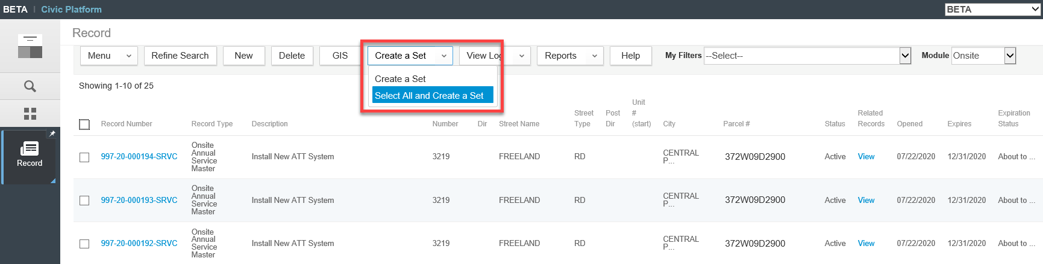

- Enter the following information > click Submit.
Set ID = [descriptive as you like – for internal use only]
Set Name = [descriptive as you like – for internal use only]
Set Type = Onsite Renewals (this must be Onsite Renewals so that you can execute the appropriate letter script)
Comments = [descriptive as you like – for internal use only]
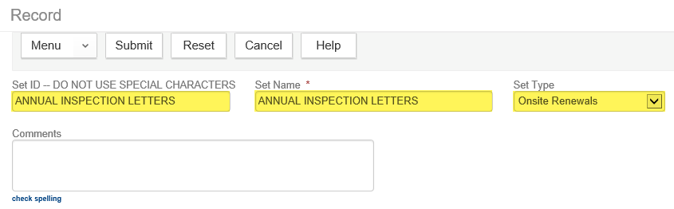

- Open the newly created Set from the Set page.
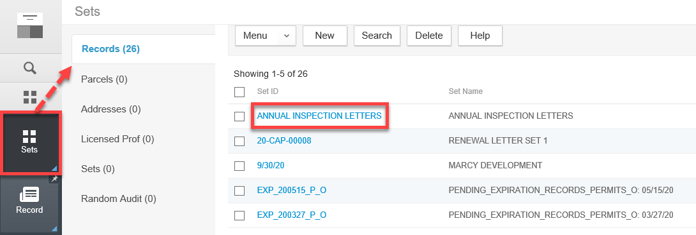

- Click on Set Member > hover over Execute Script > click ONSITE RENEWAL LETTERS TO OWNERS.
*Warning* This will generate a letter, email it to the Owner (where available), and update the workflow on the Master record.
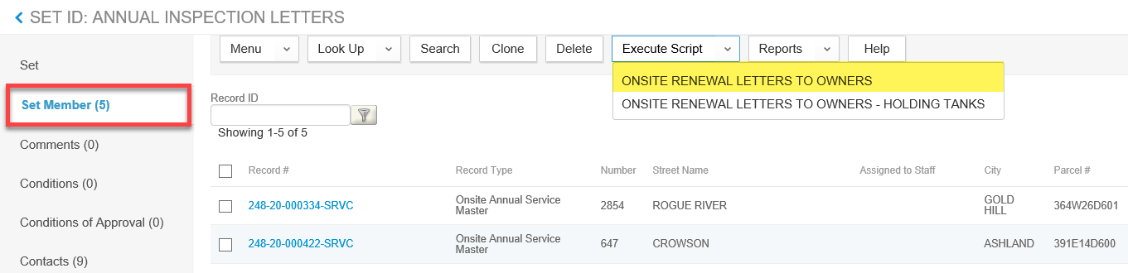

- The script could take a few seconds to a few minutes to finish executing. You will know when the script has finished because the screen will refresh and a popup window with an output of the script will display. The output displays the actions for each record in the Set.

Emailed Letter: The script first tries to email the letter to the Owner if an email address exists.
Mailed Letter: If an email address does not exist, the script will notify you that there are letters that need to be generated from the Set to print and mail through the postal service.

** Note: There is a bug in the Accela software where you cannot execute a Set script two times in a row. If you have already executed a Set script, please log out and log back in again to execute this script.

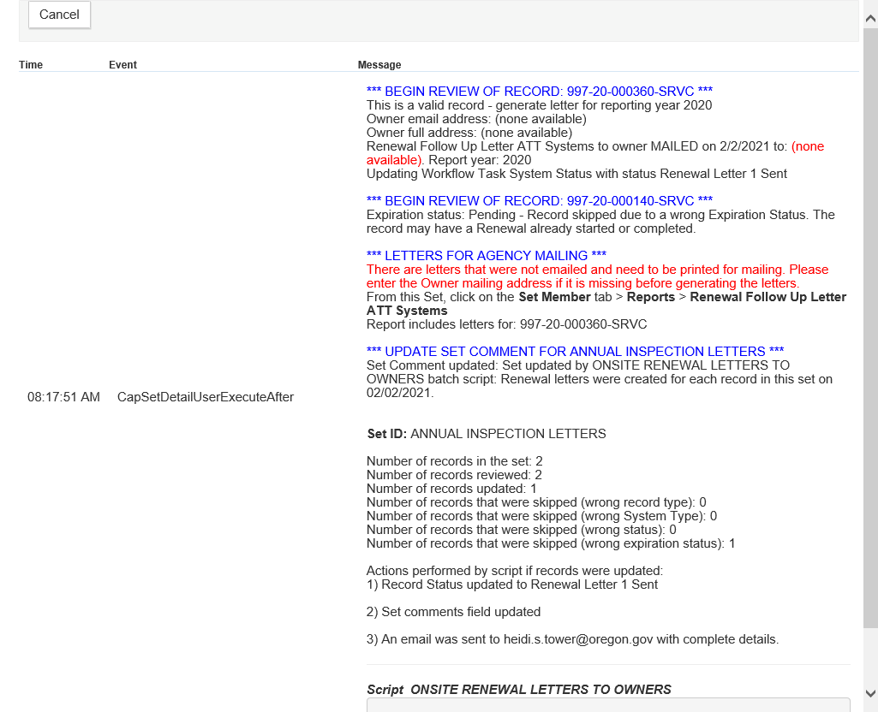

- The output will let you know if you should generate letters for physical printing and mailing through USPS, when an Owner email address was not available.
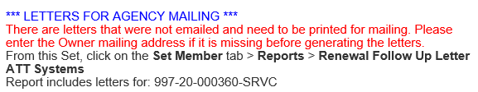

- To generate physical letters for printing and mailing, from the Set Member page > check & select the first record in the list > hover over Reports > select Renewal Follow Up Letter ATT Systems from Set.

Be sure to click Reports, not Execute Script. These two look really similar to each other.
Note: If you are not able to see the ‘Reports’ dropdown, open the Preferences page > switch your default module to Onsite > reopen the Sets page.
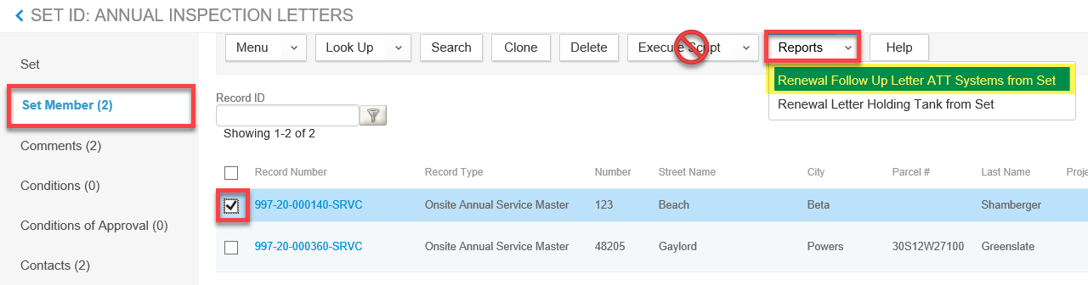

- Enter the appropriate parameter values > click Submit.

- The letters will be generated for all of the Owners that did not have an email address. Now, the letters can be printed and mailed out.
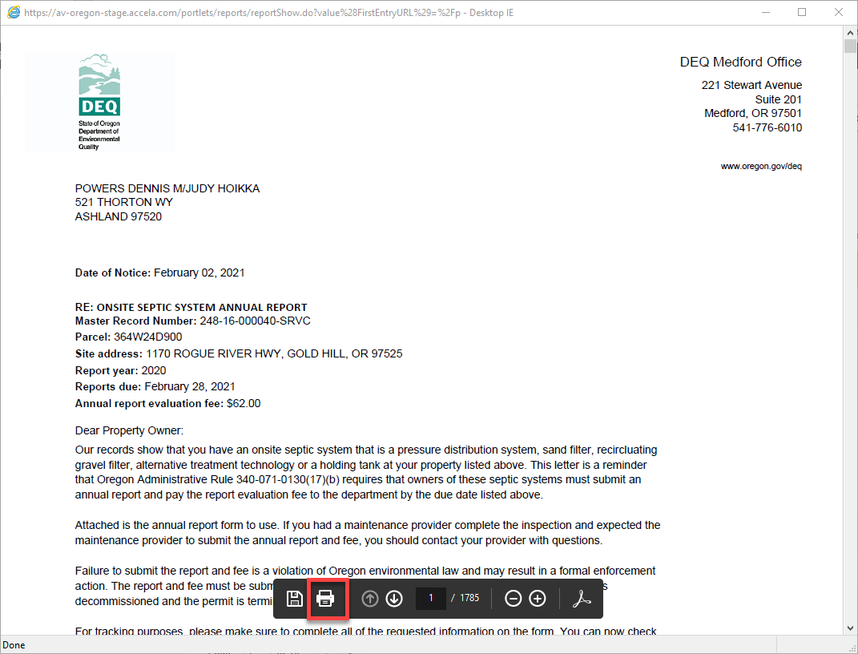

- If you need to print out another copy of the letter, you can generate it from the Summary tab > hover over Reports > click Renewal Follow Up Letter ATT Systems. Please note that if the letter was already emailed to the property owner, you will have to get a copy of the report from the Communications page.
