Get Current Reference Owner at Renewal

From the Back Office, when a Renewal record is initiated, the current Reference Owner can be retrieved from the database and will be copied to the Master record.

- From the Master record, initiate the Renewal record.
- Once the intake form is populated with last year’s data, scroll down to the Parcel section.
Note: The Owner is populated with last year’s data.
- Click Get Address & Owner.
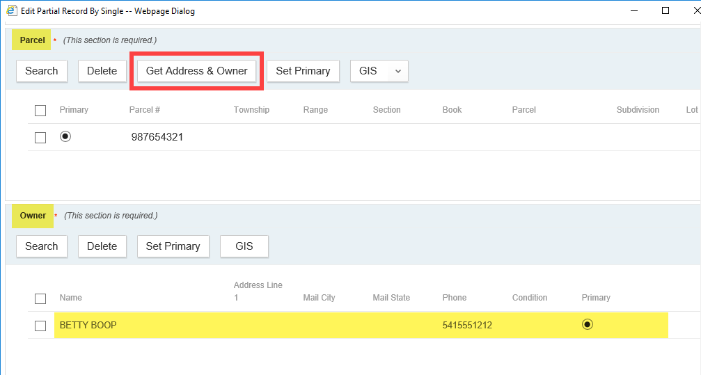

- The new Reference Owner associated with the Parcel is automatically added.
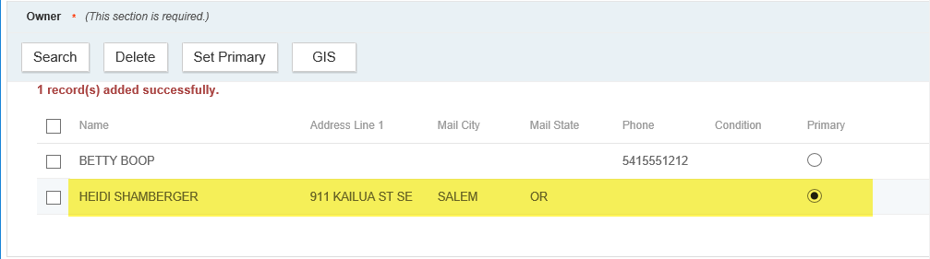

- Now, checkbox the previous Owner > click Delete. Once the Renewal fee is paid and the Renewal is complete, the new Reference Owner will be copied to the Master record.
