Back Office – Processing a Renewal when not Accepting Payment Online

Some agencies elected to not accept/require payment online for online Renewal records (annual inspection reports). This means that your customers will submit their annual inspection report data online without payment. You will be able to see their submitted records and process payment from the back office.

Note: This is what your customers will see on their end once the record is submitted:
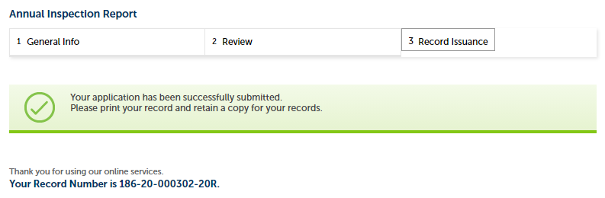

- Once the Renewal record is submitted online, you will receive an Alert.
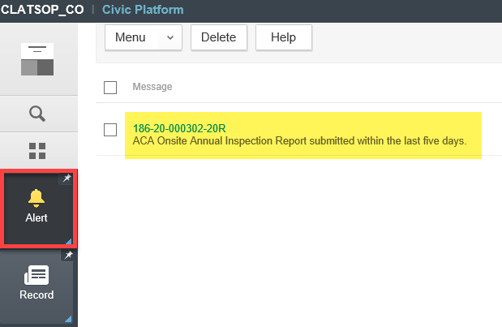

- Or you can monitor Renewal records submitted online by using the record list filter called Annual Service Renewals – Incomplete. You will notice that the Status of records that appear under this filter is Renewal Received. This means that the Renewal record is started but not complete.
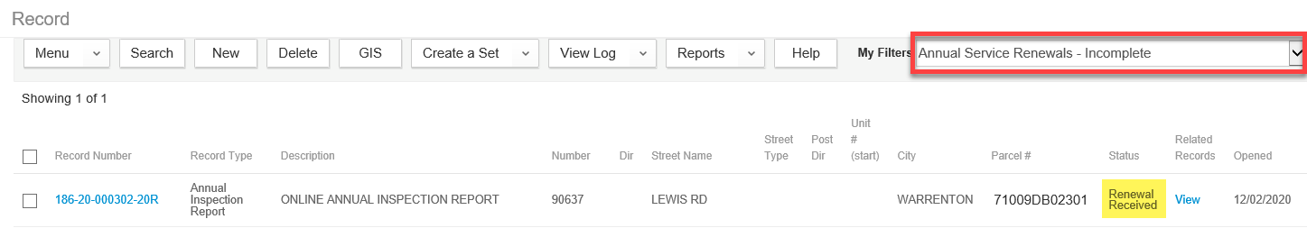

- Now, open up the record > navigate to Fees. You will notice that the fee is automatically assessed. If the fee looks correct, go ahead and Invoice the fee so that it can be paid.

- If you would like to send the Invoice report to the maintenance provider or any other appropriate party, you can click the Invoice # to generate the Invoice report.
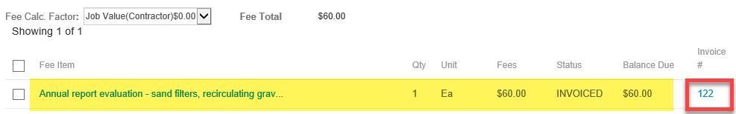

- Click Send E-Mail and send to the appropriate party.
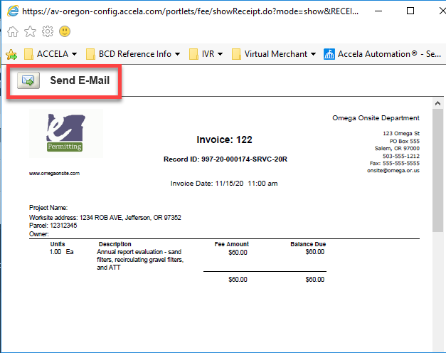

- IMPORTANT NOTE: Once the fee is paid in full from either the back office OR online, this year’s renewal is complete and ready to be submitted next year.

