Back Office – Processing a Renewal Record Started Online

A Renewal Record might be started online but not finished. In this scenario, you can complete the Renewal record in the back office. You can also use these instructions when you require payment online but have an exception where you would like the maintenance provider to submit the inspection result online but will invoice the property owner.

Note: You will see a TMP record in the Back Office once a public user starts the application online and gets as far as the Fees screen. Now, you can find the TMP record and complete it in the back office.
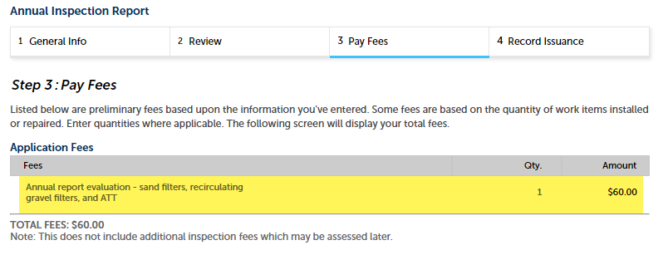

- The first step is to search for the TMP record. You can easily find TMP Renewal Records by using the Record List Filter called Annual Service Renewals – Incomplete.

- Click the TMP Record Number.
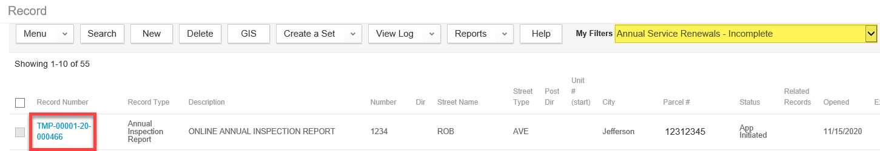

- The intake form will appear with all the information that the public user filled in. Click Submit.
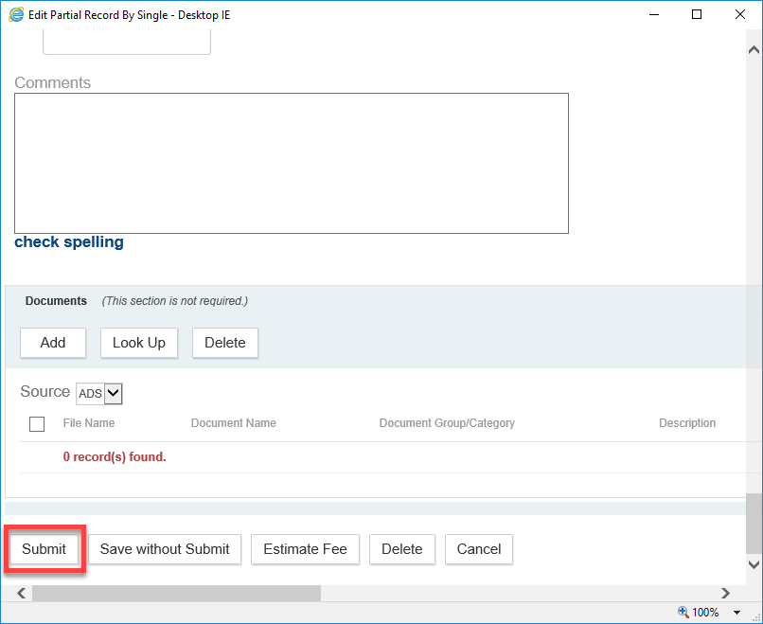
- The record will be created. You will notice that the fee is automatically assessed and invoiced.

- From here, you can click the Invoice # to generate the Invoice report to send to the property owner or any other appropriate party.
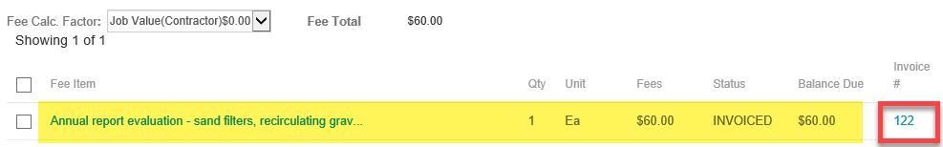

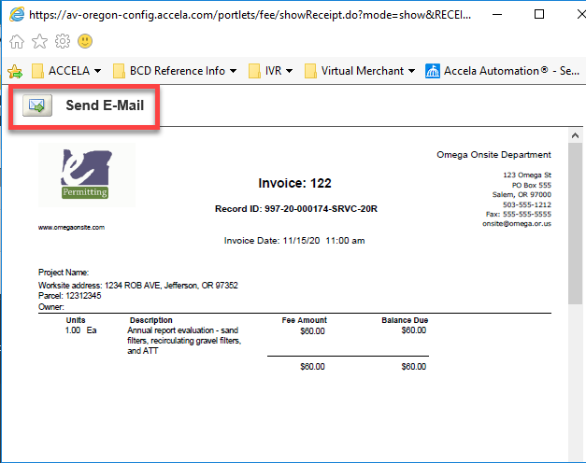

- IMPORTANT NOTE: Once the fee is paid in full from either the back office OR online, this year’s renewal is complete and ready to be submitted next year.

