Creating Conditions of Approval – Onsite Module
Conditions of Approval for a record can be created in Accela and will appear on several Onsite documents (including the Onsite Permit). This document details the steps needed to create a Condition of Approval for Onsite applications.
- Select the desired record from the Record page, and click on Conditions of Approval in your List View. This page will show all existing Conditions of Approval on the record. To add a new Condition, click “New”:
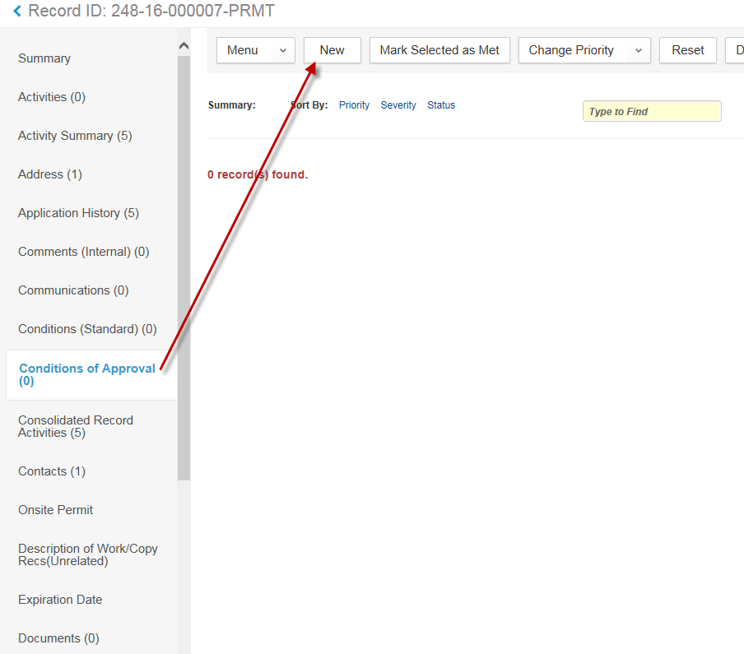
- Choose “Conditions of Approval” as the Condition Group, and click Submit:
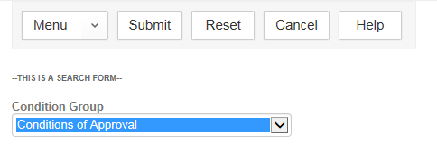
- Choose “Onsite Condition of Approval” and click Select:
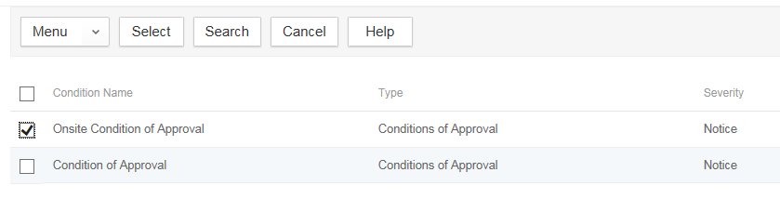
- The Condition of Approval has now been added with a default comment: “There are conditions of approval on this record which must be met”. To provide more information on the condition(s), click “Actions” > “Open”
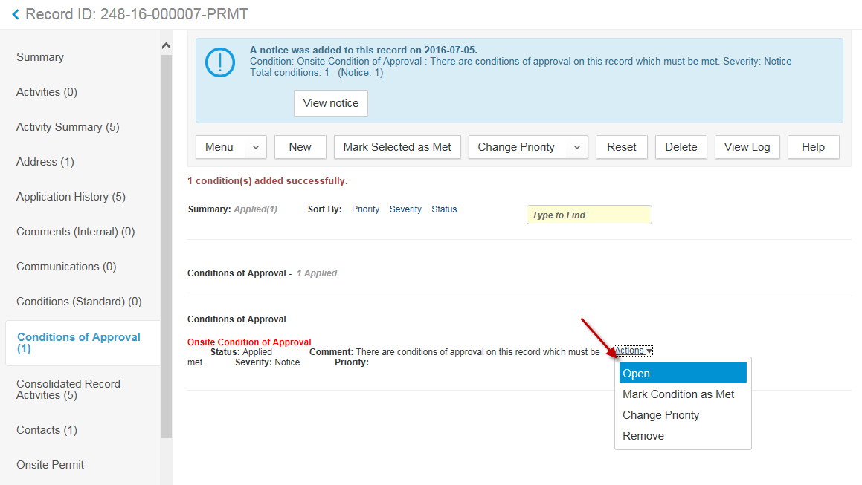
- A popup window will appear for you to input additional information. This includes a basic HTML editor, which will allow you to format your text. After updating with the necessary information, click “Save” to finalize your input.
  - NOTE: You have access to any Standard Comments loaded into your agency as well.
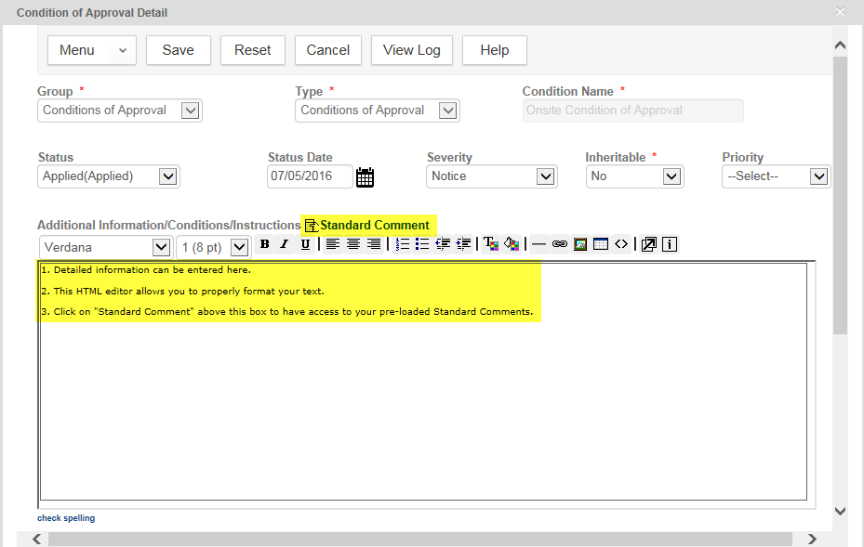
- Your Condition of Approval is complete! This will print on your Permit, Site Evaluation approval, and Authorization approval.

