Changes when Creating New Records, Starting June 28
Starting on Mon, June 28, you will notice a small change to the UI when creating a new record for
DEQ_COOS, DEQ_MEDFORD, CURRY_CO, and JOSEPHINE_CO.

- Click New to create a new record.
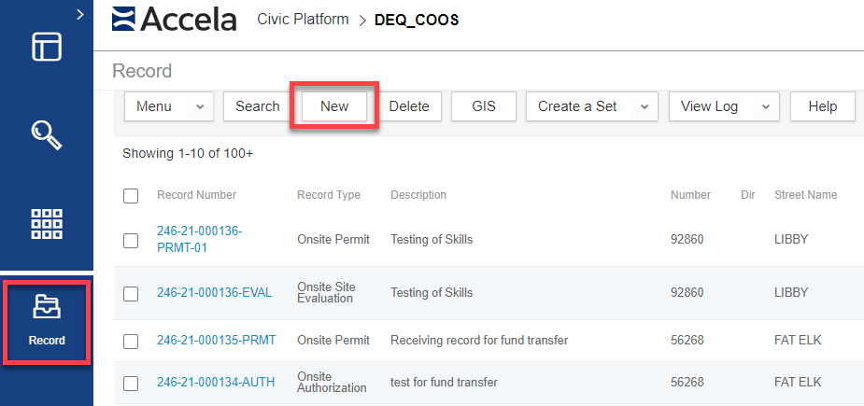

- The record selection screen will now look like the screenshot below. Expand the ONSITE group of records and click on the record type you would like to create. The remainder of the record creation process has not changed.
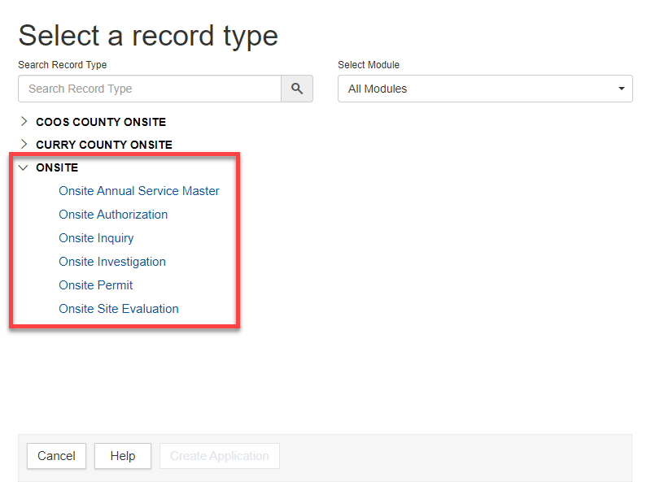

- Special Note: Depending on your agency, you will see a list of other grouped record types. In this example, I am logged into DEQ_COOS and see COOS COUNTY ONSITE and CURRY COUNTY ONSITE. But this list will be different depending on your agency. These groupings are configured for Citizen Access only so please disregard the groupings other than ONSITE.

