1.0 Contact Information - Building
(Required – there are no system defaults)

Jurisdiction:
Submitted by:
Date:

Report Header Example:
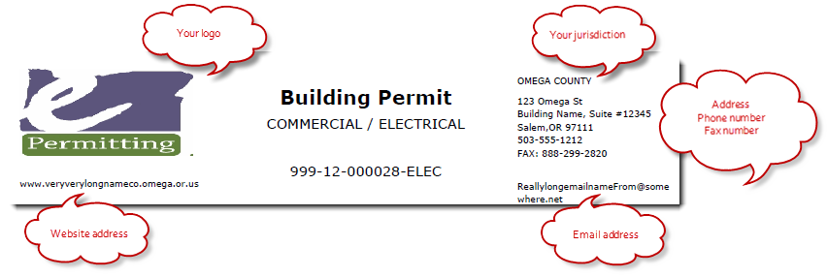
For which Module: Building Module
Address Line 1:
Address Line 2:
City and Zip:
Primary Phone number:
Fax number:
Additional Phone 1: (OPTIONAL - please indicate what phone is for)
Additional Phone 2: (OPTIONAL - please indicate what phone is for)
Website address:
Email address: (should not be an individual – appears on all reports such as permit, inspection, etc)
Signing Official: (is Building Official for the Building Module, may differ by module)
Payment Terms: (default payment terms included on fee invoices, ie. due upon receipt, NET 30 days, etc)
New Dwelling Limited: (if you do not provide permits for a certain discipline, please indicate which discipline it is, ie. Electrical, and who provides those permits for your jurisdiction with a phone # to contact them, ie. Clackamas County at 503-xxx-xxxx)
Comments:

