1.0 Contact Information (Public Works)
(Required – there are no system defaults)

Jurisdiction:
Submitted by:
Date:

Report Header Example:
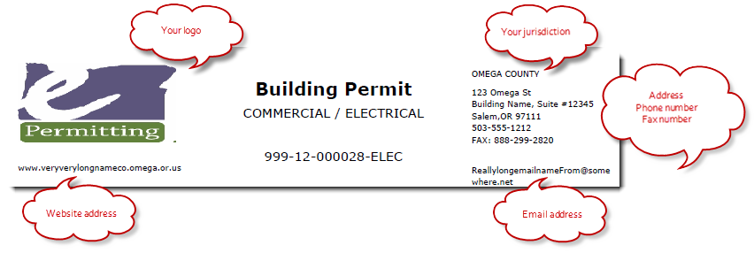
Public Works Permit

999-16-000056-PW

Address Line 1:
Address Line 2:
City and Zip:
Primary Phone number:
Fax number:
Additional Phone 1: (OPTIONAL - please indicate what phone is for)
Additional Phone 2: (OPTIONAL - please indicate what phone is for)
Website address:
Email address: (this will appear on reports including permits, receipts, inspections, etc.)
Signing Official:
Signing Official’s Title:
Comments:

