1.0 Contact Information – Point of Sale (POS)

Jurisdiction:
Submitted by:
Date:

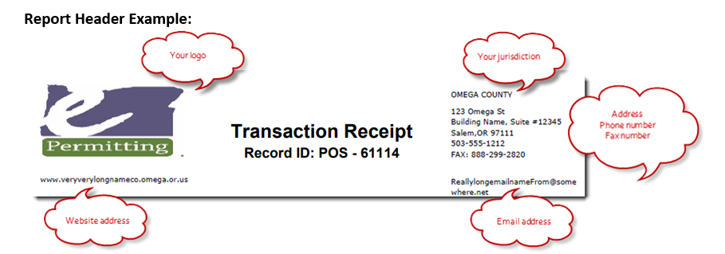

For which Module: Point of Sale page/receipting
Address Line 1:
Address Line 2:
City and Zip:
Primary Phone number:
Fax number:
Website address:
Email address: (should not be an individual – appears on all receipt reports)
Comments:

