1.0 Contact Information - Planning
(Required – there are no system defaults)

Jurisdiction:
Submitted by:
Date:

Report Header Example:
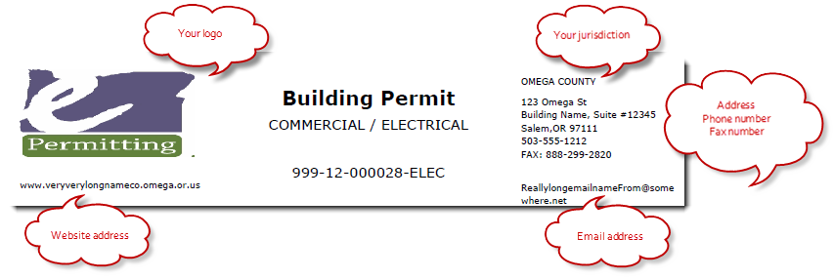
Planning Report

999-14-000124-PLNG

For which Module: Planning Module
Address Line 1:
Address Line 2:
City and Zip:
Primary Phone number:
Fax number:
Additional Phone 1: (OPTIONAL - please indicate what phone is for)
Additional Phone 2: (OPTIONAL - please indicate what phone is for)
Website address:
Email address: (should not be an individual – appears on all reports such as permit, inspection, etc)
Signing Official: (is Building Official for the Building Module, may differ by module)
Payment Terms: (default payment terms included on fee invoices, ie. due upon receipt, NET 30 days, etc)

Comments:

