How to set Preference Management to view data across Modules

- If you haven’t already, locate and favorite the Preference Management page – Launchpad > All Pages dropdown list > favorite the Preference Management page to add it to your Launchpad group. Other recommended pages for your Launchpad group might also be My Tasks and Inspections – these two pages do not have the Module dropdown available to them as the Record List does, so they only display data as per your preferred module selection. Seeing all of your assigned items as a user, across modules, is key so that you are not unknowingly missing anything assigned to you or others (Inspections, Workflow tasks like Plan Reviews, Activities).
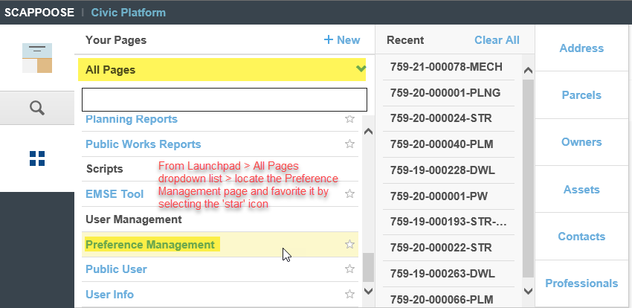
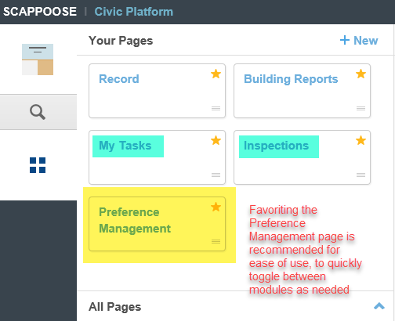
- First before selecting a Preferred Module, make sure all pages are closed – this is important so that all impacted pages will refresh to show data for your preferred module selection. When selecting a Preferred Module, you will only see those modules that you have permissions to. For example, if your user does not have any user permissions for Planning, you will not see the Planning Module as an available selection in the dropdown.
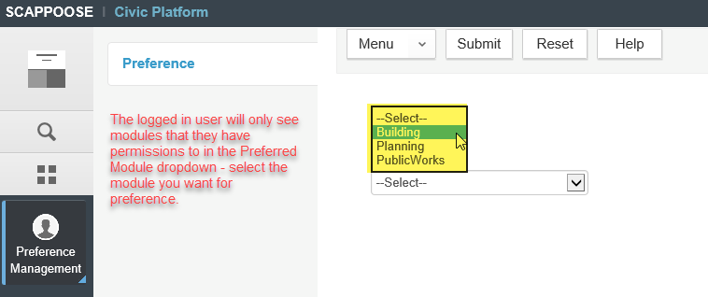
- Once a Preferred Module is selected, you can open various pages – My Tasks and Inspections are pages that rely on your module selection.
My Tasks page – data and filters
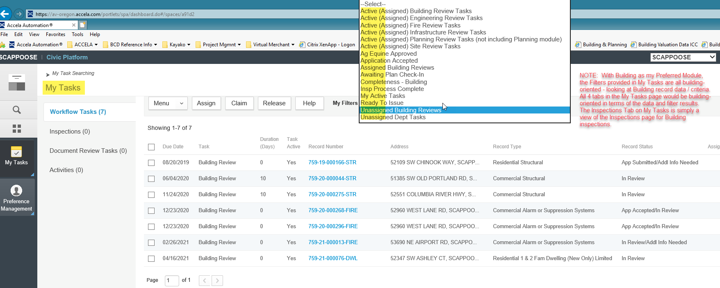
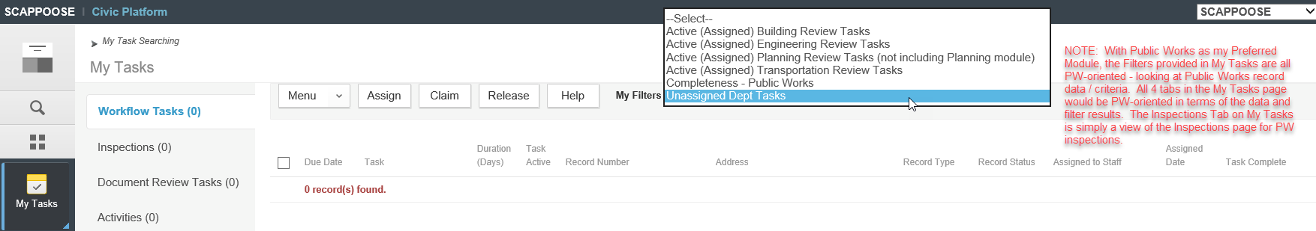
Inspections page – data and filters
