Planning Module – Tree Record Type
(Application Information – Shared Dropdowns and ACA Option)
____________________________________________________________

Jurisdiction:
Submitted by:
Date:

Your agency is being provided with this submittal form if you have decided to track Tree Permits in the Planning Module. The Oregon Model provides a dedicated Record Type for Trees, available for online application on ACA. The intake includes some basic information about the trees and a Tree Application Specific Information Table (ASIT or Custom Table) where the applicant is able to add additional details. In the Tree record type, there are two dropdown fields that are customizable for your local agency.

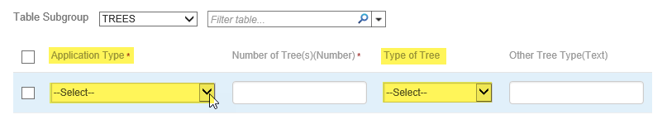

The two customizable dropdown fields provided are designed to provide a greater level of application detail when “Tree” is the selected Planning Record Type.

Please provide the dropdown values for the following application fields:
(please provide each Dropdown as a list in a separate text file such as Notepad)

Custom Tree dropdowns:
  - Tree Application Type (This would be the specific tree application type. For example: Hazardous, Emergency, Tree Topping, Tree Protection, Invasive Species, Forest Management, Verification, Type 1, Type 2, etc.) [PLN – Tree Application Type]
  - Type of Tree (specific species of trees that are found in your local jurisdiction. For example: Alder – Red, Ash – Oregon, Cottonwood – Black, Dogwood, Fir – Douglas, Fir – Grand, Fruit Tree, Maple – Big leaf, Maple – Red, Oak – Oregon White, Pine Species, Sweetgum, Willow Species, etc) [PLN – Type of Tree]

Online Application Option - the Tree record type can be made available online for application only – would you like to offer this record type online on ACA:
☐ Yes – please complete reverse side of form
☐ No
Instructional Text Online - when offering this record type for online application, you have the option to add instructional text, links to information on your agency website – anything they need to know or do regarding this application. If no text is provided, your agency contact information will be indicated for questions/assistance.

On this note, there is an OPTIONAL Additional Information Section online where the customer can break down their application request more specifically by adding rows to a table, including specifying the Type of Tree(s) involved. If you are interested in having applicants fill this section out for your agency to gather added information, consider giving them instructions to do so – see example below.

Example:
“A site plan is required with your application. Not attaching a site plan will delay the processing of your permit/application. For information on requirements for your site plan please see here [hyperlink reference to information on your agency website]. If you application is for the removal of trees please complete the Additional Application Information section below by clicking on Add a Row. Please add additional rows as necessary for your application. Documents can be uploaded during the next step (after clicking Continue Application).”

Enter instructional/informational text below:

Agency contact information - if the applicant needs assistance or has questions – this information is required for online configuration:

Agency and Specific Department/Section Name:
Contact Phone:

Important note: if your agency does not already accept online payment – you might want to consider turning on the option for online payments in Planning with the addition of this record type. The fees are not automated but your agency may wish to accept payments online after you manually assess/invoice fees.

