Service Lock Conditions on Addresses

Introduction:
Service Lock Conditions are used in scenarios where the County provides only specific permit services for Cities within their boundaries, like Electrical, but they do not provide other services, like Mechanical, Plumbing, or Structural. The Service Lock Conditions are applied to the address and “lock” or hide services that do not apply.

For example:

119 NW Beaver Ct, Dallas, OR 97338

- This address belongs in the City of Dallas and is within Polk County.
- This address exists twice in the Accela database:
1) for City of Dallas
2) for Polk County
- Polk County provides only the Electrical permit services for this address.
- City of Dallas provides all other permitting services for this address.

For the Polk County address, Service Lock Conditions are added for all services, except Electrical. This configuration allows Citizen Access to display the correct services under the correct agency. It also prevents the wrong record type from being created in the Accela Back Office product as well.

Citizen Access:
Public users in Citizen Access see the following for this example address. City of Dallas provides all permitting services. And Polk County provides only the Electrical permitting service.
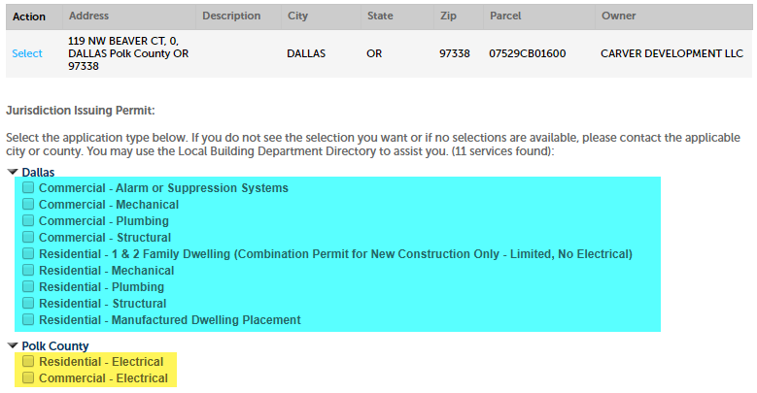

If Service Lock Conditions did not exist on this address for Polk County, public users would see the following. Both Polk County and City of Dallas are showing the same services. This adds confusion for the public user. Additionally, they can incorrectly select the permit service in Polk County, like Mechanical, and a permit would be created for the wrong agency.
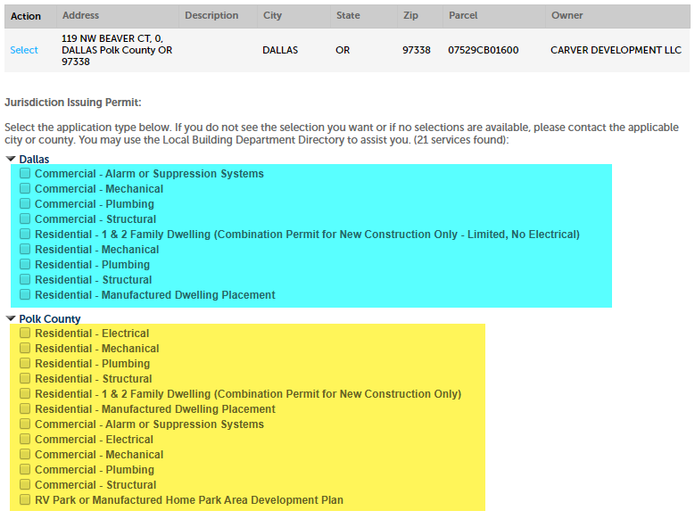

Back Office:
County staff will see the following message if they attempt to create a new record for a record type at an address that they do not permit for, based on the Service Lock Conditions. They will also be prevented from creating the record.
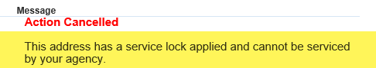

Automated Batch Script to Add Service Locks:
Service Lock Conditions are added automatically with a database batch script that is run on a nightly basis. First, the script looks at each parcel and evaluates the values on the following Parcel Attributes:

- Electrical Jurisdiction
- Mechanical Jurisdiction
- Plumbing Jurisdiction
- Structural Jurisdiction
- Septic Jurisdiction

Secondly, if the value is NOT the jurisdiction, then a Service Lock Condition is needed and added to the associated address(es).

For example:

- If Electrical Jurisdiction = Polk County > then:
  - No Service Lock Condition is added for the County address.
- If Mechanical Jurisdiction = Dallas > then the following Service Locks are added to the County address(es):
  - Commercial – Mechanical
  - Residential - Mechanical
- If Plumbing Jurisdiction = Dallas > then the following Service Locks are added to the County address(es):
  - Commercial - Plumbing
  - Residential - Plumbing
- If Structural Jurisdiction = Dallas > then the following Service Locks are added to the County address(es):
  - Commercial – Alarm or Suppression Systems
  - Commercial – Demolition
  - Commercial – Structural
  - Residential – 1 & 2 Family Dwelling (Combination Permit for New Construction Only)
  - Residential – Manufactured Dwelling Placement
  - RV Park or Manufactured Home Park Area Development Plan

The Conditions can be seen in the Back Office. Go to the Launchpad > open the Reference Address page > search for the appropriate Address > navigate to Conditions:
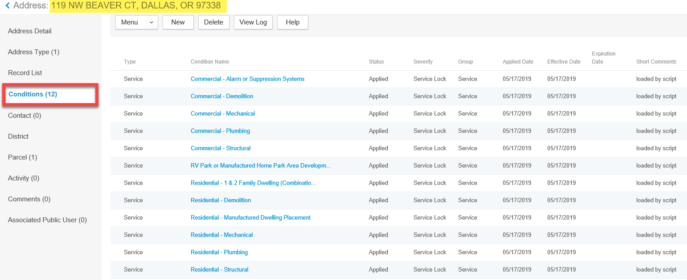

Agency’s Data Responsibility:
Agencies that need Service Lock Conditions must maintain the data values in the Parcel Attributes mentioned above. These can be maintained in two different ways:
- Manually through the Accela Back Office product in the Reference Parcel page.
- Automatically through a routine APO load by populating the parcel_attr.txt file.

Accela Back Office:
- From the Launchpad > open the Reference Parcel page > search for the appropriate Parcel > navigate to Parcel Detail > scroll down to the Jurisdiction Parcel attribute fields.
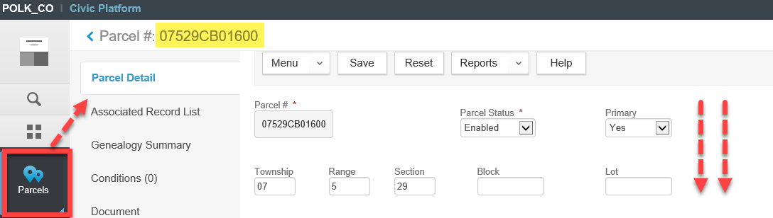

- Select the permitting agency for each dropdown value > click Save at the top. The Service Locks won’t be applied immediately. They will be added that night (around 4:00 AM) through the automated batch script mentioned above.
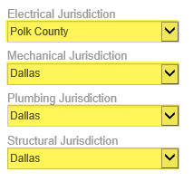

Routine APO Load:
- Locate the file named parcel_attr.txt file.
- Add 4 rows for every parcel; one for each “Jurisdiction” Parcel Attribute field:
  - Electrical Jurisdiction
  - Mechanical Jurisdiction
  - Plumbing Jurisdiction
  - Structural Jurisdiction
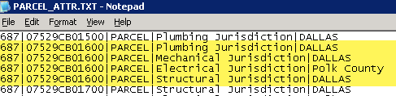

- This file will automatically populate the Parcel Attribute fields once the APO load is run.
- The Service Lock Condition automated batch script (mentioned above) will run, following the APO load, and add the appropriate Service Lock Conditions to the address(es).

