How to Create a Tree Permit in the Planning Module

- Select NEW to create a new application – Planning > Planning Tracking > N/A > Comprehensive
- Once the intake form loads, fill in the required fields noted by an asterisk (*). Enter the Parcel where the tree(s) are located, select Search to look that parcel up to add to your application.
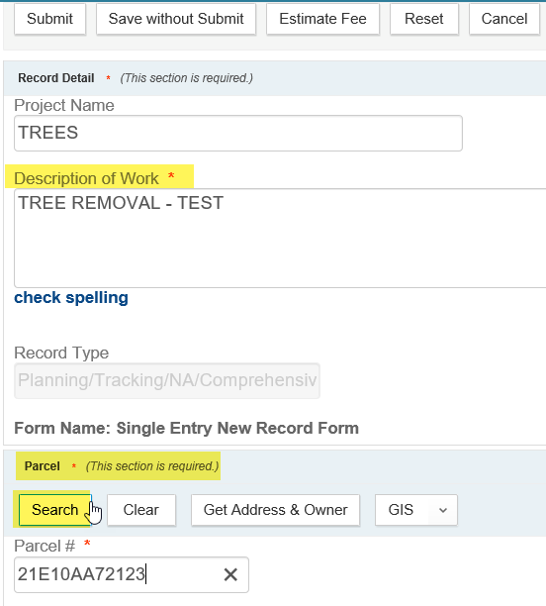
- Once the matching parcel is found, the associated Owner and Address will pop up (may be just Owner if the parcel has not been developed yet) – select the pieces to add to your application.
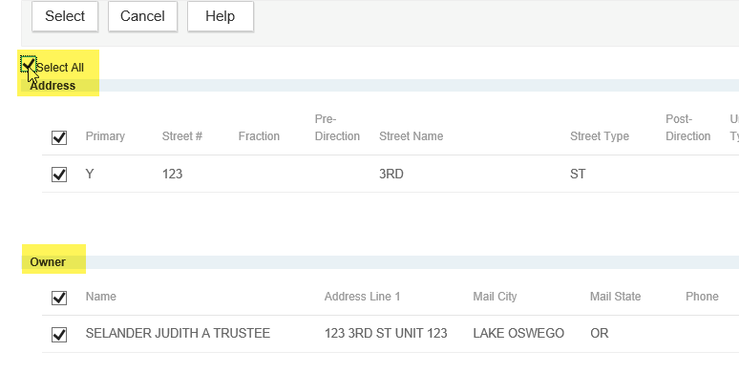
- Applicant is the next required section. You can use the As Owner (or As Lic Prof is you had optionally added a Licensed Professional/Contractor) – or you can enter the required information indicated in the applicant form – note Primary Phone is required and is often not populated automatically. While Email is not required, it is highly recommended in order to take advantage of added system functionality. Note, the red statement at the top is NOT an error – just input guidance.
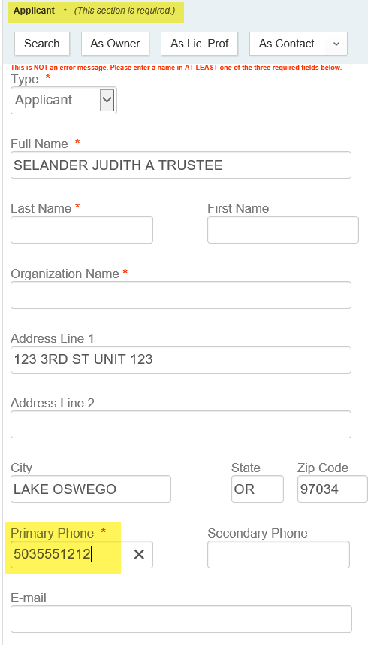
- While not required, there is a Tree application specific information (ASI) section included on the intake form – these fields should be filled in when applicable. Once complete, click Submit to create your record.
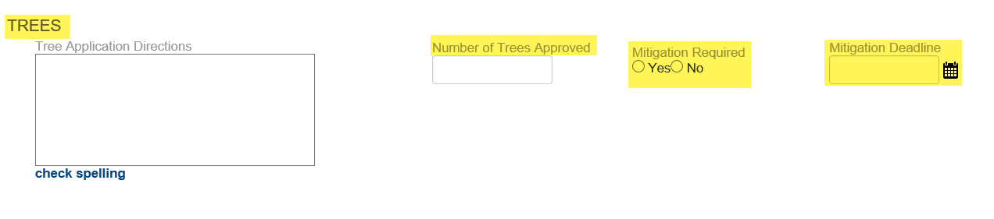
- Your record will be created, click it open from the Record list page. Once you open your record, go to the Custom Tables tab in the Navigation pane – in the Table dropdown, select Trees.
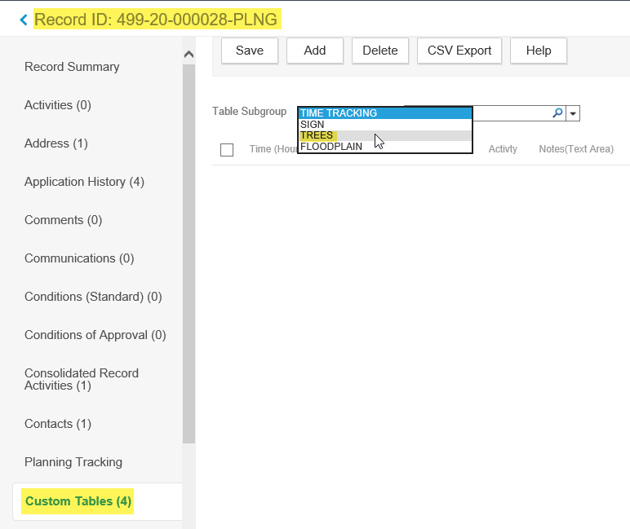
- Select ADD to add a row of Tree detail information. Enter the required information and any other details as needed.
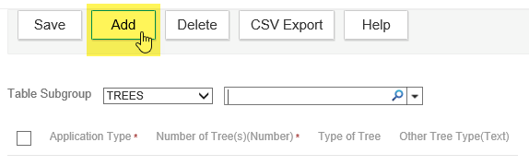 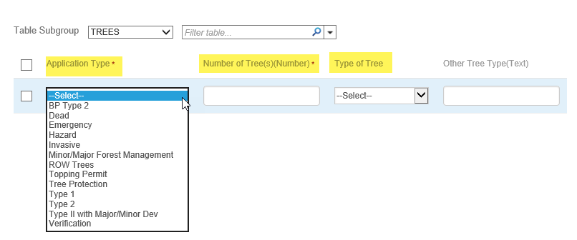
- Go to the Fees tab and ADD to add any applicable fees. Invoice these when you are ready to collect payment. Go to the Payment tab to receipt payment.
- Go to the Workflow tab > open the Application Intake task. You can result this task as Issue Permit/Decision which will immediately jump to issuance, generate the Permit report, and close the record in one fell swoop – you would only use this result IF there were no staff review and no inspections required. Alternatively you can result this task as Application Deemed Complete – this will advance the record to the Staff Review task in preparation for some form of review and potentially for inspection.
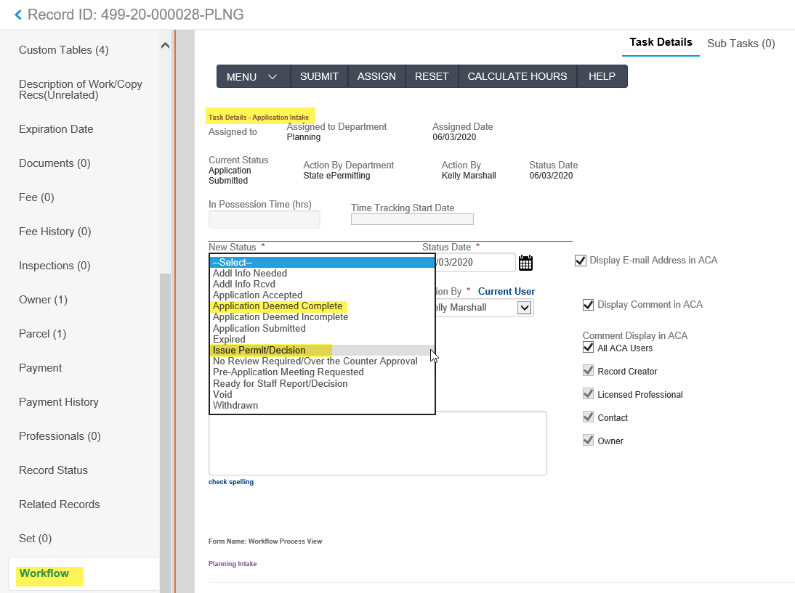
- If you selected Application Deemed Complete, the record advanced to Staff Review – click the Staff Review task open. You can result this task as either Issue Permit/Decision – Final Insp Not Rqd – or – Issue Permit/Decision – Final Insp Rqd. This will depend on if your agency requires inspections on these permits or not. If you select Issue Permit/Decision – Final Insp Not Rqd, the record will be issued, the Permit report generated, and the record closed given no inspections are required. See the next step for selecting Issue Permit/Decision – Final Insp Rqd.
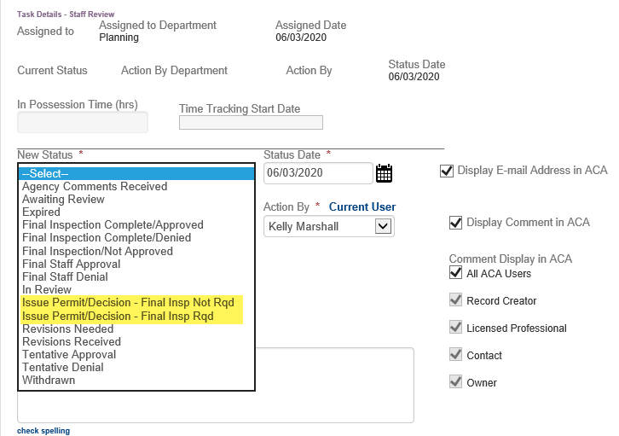
- If you select Issue Permit/Decision – Final Insp Rqd, the record will be issued, the Permit report generated, but the Workflow will remain at the Staff Review task and the record open as it requires inspection(s). Inspections would then be scheduled by the applicant or the agency on the Inspections tab. Once Final inspection is scheduled and positively resulted (Approved), staff would return to the Workflow, open the Staff Review task and result the task either as Final Inspection Complete/Approved or Final Inspection Completed/Denied – whichever is applicable. Both results will close the record.
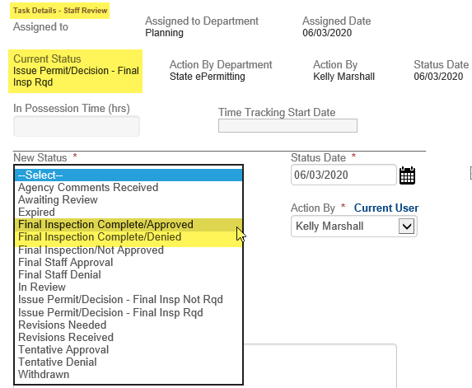
Below is Planning Workflow Diagram related to steps #9 to #11.
