Planning Module – Tree Application Table
(Application Specific Information – Table Dropdowns)
____________________________________________________________

Jurisdiction:
Submitted by:
Date:

Your agency is being provided with this submittal form if you have decided to track Tree Permits in the Planning Module. The Oregon Model provides several tree application fields as well as a Tree Application Specific Information Table (ASIT or Custom Table). In the Tree ASIT, there are two dropdown fields that are customizable for your local agency.

The two customizable dropdown fields provided are designed to provide a greater level of application detail when “Tree Permit” is the selected Planning Application Type.

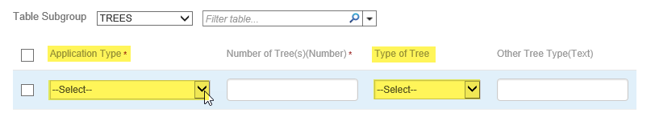

Please provide the dropdown values for the following ASIT fields:
(Please provide each Dropdown as a list in a separate text file such as Notepad)

Custom Table - Tree dropdowns:
  - Tree Application Type (This would be the specific tree application type. For example: Hazardous, Emergency, Tree Topping, Tree Protection, Invasive Species, Forest Management, Verification, Type 1, Type 2, etc.) [PLN – Tree Application Type]
  - Type of Tree (specific species of trees that are found in your local jurisdiction. For example: Alder – Red, Ash – Oregon, Cottonwood – Black, Dogwood, Fir – Douglas, Fir – Grand, Fruit Tree, Maple – Big leaf, Maple – Red, Oak – Oregon White, Pine Species, Sweetgum, Willow Species, etc) [PLN – Type of Tree]

