OSM Workflow Enhancements
Available in production Tuesday, September 3rd

Two new adhoc workflow tasks
- ‘Issue New C of O at Completion’ – created as an optional way to notify staff that a new C of O should be issued at completion for addition/alteration records where a new C of O would be appropriate
- ‘Septic Authorization Required’

‘Permit Issuance’ task will now be updated with a status of ‘Permit Issued’ when the permit has been issued ‘over the counter’ from the ‘Application Intake’ task
Currently, while the overall record status is updated to ‘Permit Issued’, the permit task does not get an entry. This change will be made to all applicable record types in Building, Onsite and Public Works modules.

Before this update when the permit was issued from the ‘Application Intake’ task, that task would reflect ‘Permit Issued’, the review task(s) would indicate ‘Not Required’ and while the ‘Permit Issuance’ task would be closed and categorized as completed, it was not updated with the status of ‘Permit Issued’:
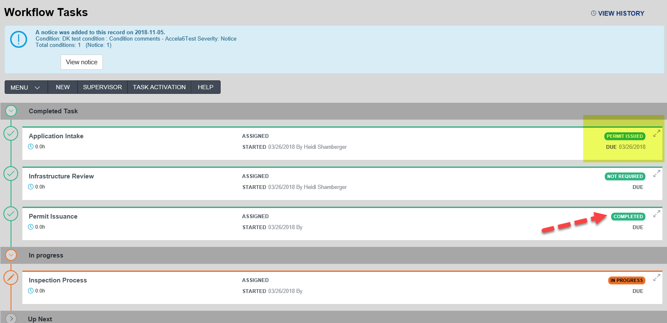

Following this update, the ‘Permit Issuance’ task will now show a status of ‘Permit Issued’:
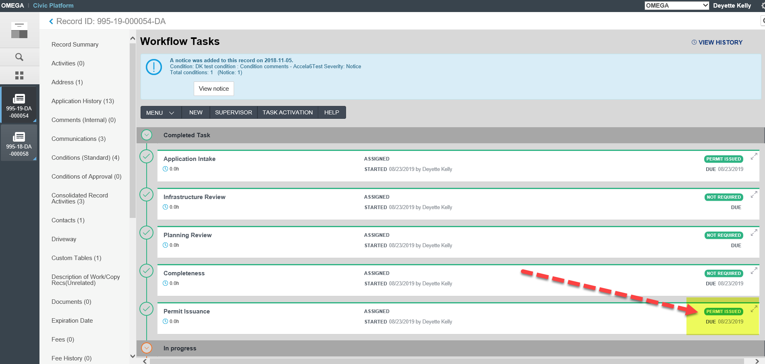
A ‘Completeness’ task has been added to electrical, mechanical and plumbing record types as an optional step to allow staff to prepare the permit for issuance following a review
From the review task, selecting a status of:
- ‘Approved for Completeness’ will advance the record to the ‘Completeness’ task, allowing staff to prepare plans, add fees etc., prior to making the record ‘Ready to Issue’. It will not update the overall record status
- ‘Approved’, ‘Approved with Conditions’ or ‘Not Required’ will skip the ‘Completeness’ task and open the ‘Permit Issuance’ task with a record status of ‘Ready to Issue’
- Records issued from ‘Application Intake’ will skip the ‘Completeness’ task along with the review task
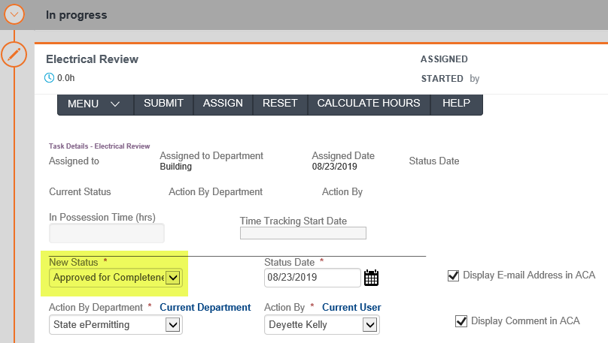

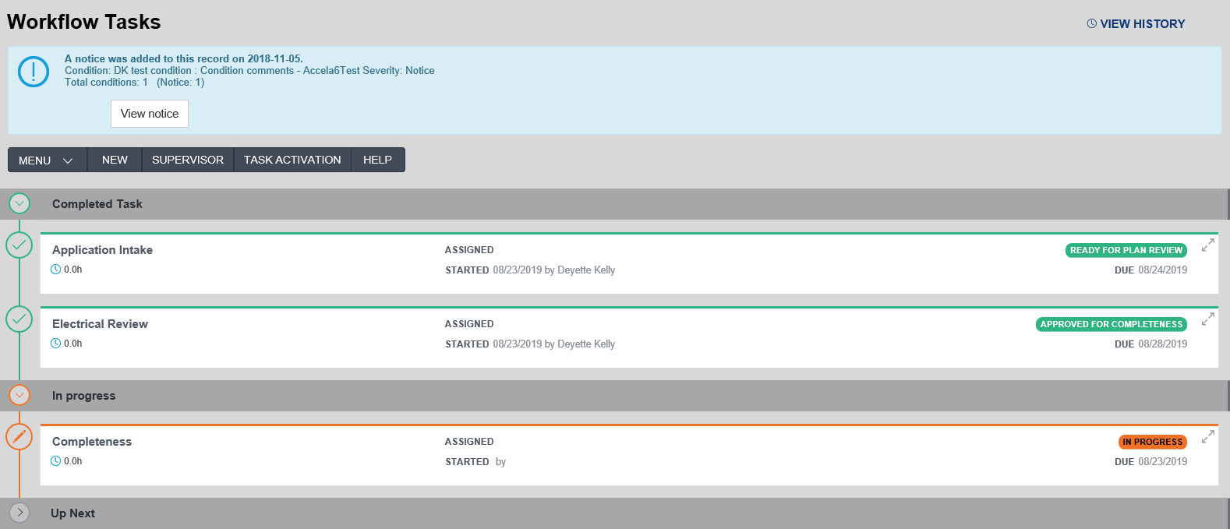

Change to task statuses for Onsite Permit record type
A new status of ‘Site Visit Complete’ replaces the following statuses:
- ‘Construction Permit Site Visit Complete’
- ‘Repair/Alt Permit Site Visit Complete’

Two new tasks added to the Driveway Access permit (in the building module only):
- ‘Planning Review’ is added as a parallel task to ‘Infrastructure Review’
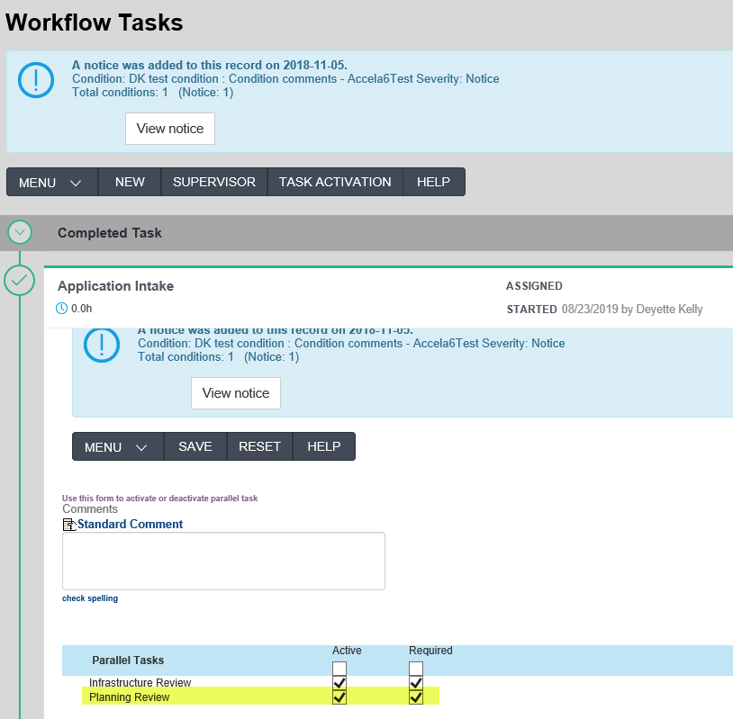

- ‘Completeness’ is added to pull the reviews together in preparation for permit issuance
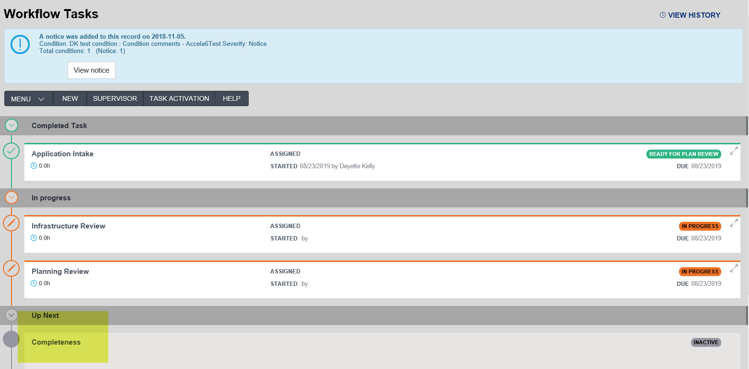

Two additional parallel tasks have been added to the Commercial and Residential Demolition record types
- ‘Infrastructure Review’
- ‘Site Review’

Updates to Investigation record types (in all modules)
- ‘Investigation Closed’ is a new status available in the ‘Investigation Process’ task and will close the record. The status was added to allow an agency to close the record when the agency is either unable or unwilling to pursue the investigation.
- Workflow email notification functionality added to the ‘Investigation Process’ task

Updates to Inquiry records now include a “Void” status (in all modules)
- ‘Void’ has been added as a task status with required TSI (Task Specific Information)
- Workflow email notification functionality added

Added workflow email notification functionality to the review process for Agricultural Equine record type

