Get Record Deep Link

- Go to Citizen Access without the wrapper. It is the normal Citizen Access URL + welcome.aspx
https://aca-oregon.accela.com/oregon/welcome.aspx
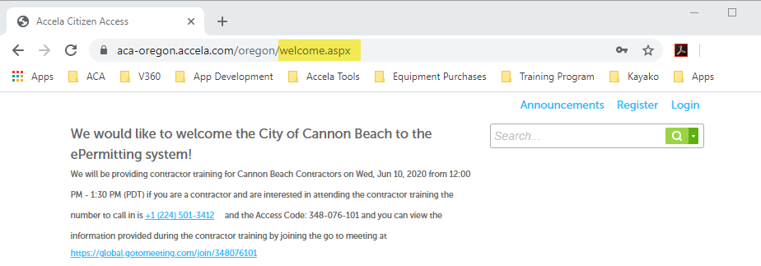

- Search for the appropriate record.
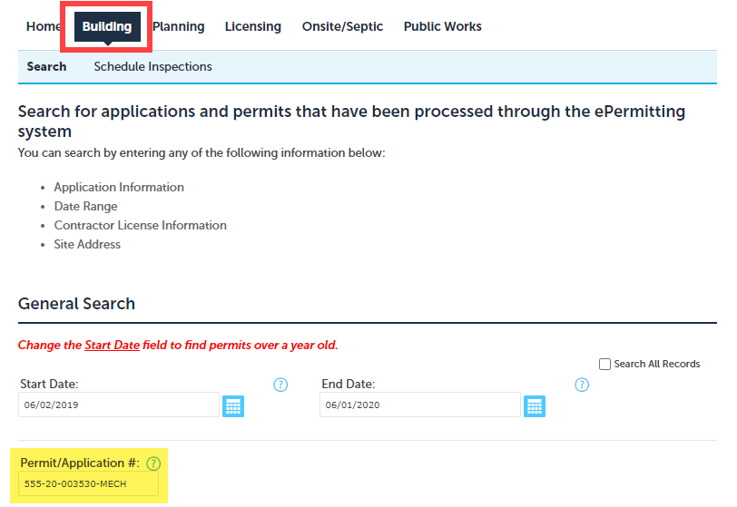

- When the record appears, select and copy the URL. This is the deep link.
https://aca-oregon.accela.com/OREGON/Cap/CapDetail.aspx?Module=Building&TabName=Building&capID1=20CAP&capID2=00000&capID3=003DJ&agencyCode=MARION_CO&IsToShowInspection= 