HOW TO CREATE A REVISION RECORD

Revisions are generated thru workflow and create a separate related (child) record – plan review only, is not a permit
Revision by Definition – the request for a material change in the submitted plans for a project – either by the Applicant or the Agency – and occurs most commonly at application during plan review, or less commonly post-issuance at inspection. A revision requires additional plan review and approval before commencing any work included on the revised plans and often times continued work on the original plan.

Launch a revision record from Workflow > from any Review task or the Inspection task, but are invoked most typically from a review task – steps to follow.
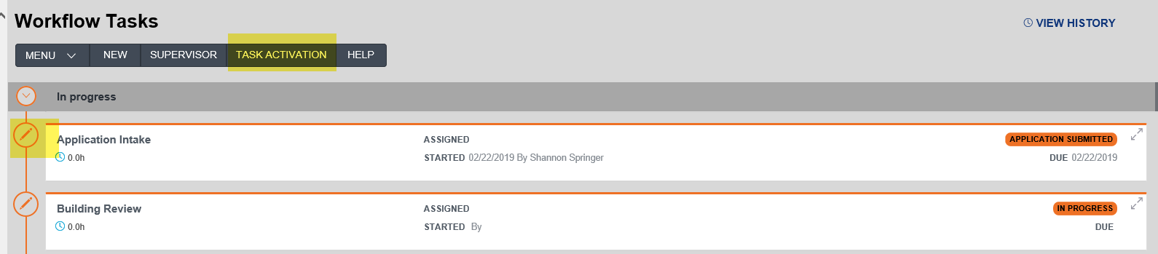
Options for handling Revisions: Additional Info Needed/Received or Revisions Requested/Received.
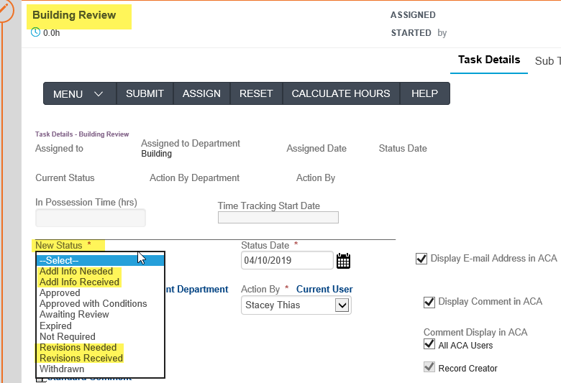
Primary differences are that using Revisions Requested/Received provides the detail and tracking of the review/approval process of the revised plan submittal separate from the review of the original plan submittal.

Revisions Needed - Comments and Conditions: automatically emails the customer whatever you enter into the Comments field – be clear about what you need revised and instructions on submitting those changes:
Revision needed – plan overlaps setbacks. Please submit revised plan by Friday to our office located at 123 Main St.

Revisions Received: once the revision is received, you must go into the system and record this. The reason you must receipt that it was received is to close the loop, as we have reports that track the plan review process and the received result restarts the timeline ‘clock’ as it is back at the agency. Once you receive the requested revision, upon resulting – the system will then automatically create a child revision record.

The child revision record created is only a plan review record, should never have inspections and can never be issued as a permit - you should collect hourly plan review fees (not percentage based) > fees > add ‘additional plan review by the hour’. This fee will have to be paid prior to final inspections. Go to workflow, accept the revision at the Revision Acceptance task, then parallel tasks will open and you should decide who now needs to review the revised plan. Once all the review tasks indicated are approved, the workflow will advance to the Revision Completeness task. You indicate the revision is complete and the child record closes.

Additional Info Needed/Received: this result does not create a child record, only indicates that you asked for something and they turned something in - so should that ‘something’ need additional review, you would then have to manually Supervise in to workflow and reopen previously completed review tasks which could potentially be very messy.

Child Revision records have only review tasks included in the workflow.

How to: Select the “Revisions Requested” result on parent record – on any review or inspection task - and input specifically what you need in the Comments.

A workflow email is then automatically generated in the background and sent to the Applicant indicated on the record and saved on the record under the Communications tab.

Note: If no email address is available for the Applicant, then other manual form of contact must be made with customer/applicant to notify them of this request.

When the customer turns in what was requested, select the “Revisions Received” status and this result will automatically generate a new related child Revision record.
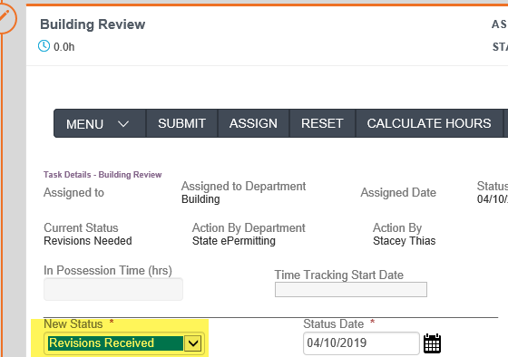

Note: the child record will be created and you will need to go to the record list to locate the new revision child record or to the Related Records tab on the parent record.
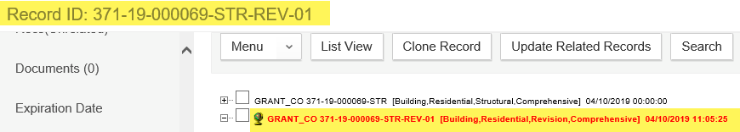
Creating a Revision record will automatically post a Notice Condition on the parent and child revision records indicating a revision has been submitted, this is very helpful and informative to internal staff and anyone externally tracking the record’s progress thru ACA.
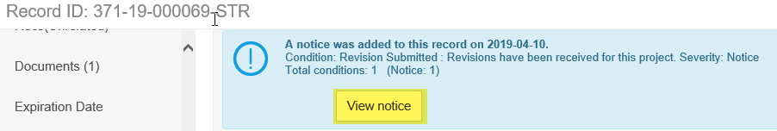

Go to the revision child record and open up the workflow tab, select the “Request Accepted” status.
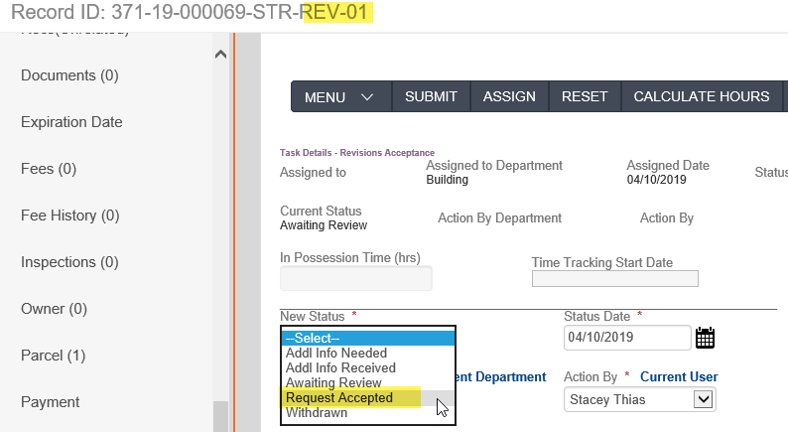
“Request Accepted” status will open the Parallel Task window with all the plan review task options listed, select what is specifically required for review on the specific revised plan submittal based on the changes.
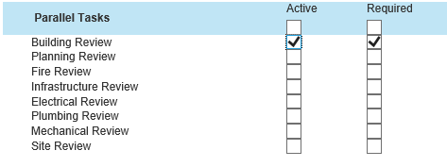

Note: Permit and Plan Review fees for the overall permit/project only occur on the Parent Permit record, as well as all Inspections – the only fee on the Revision plan review record is “Additional Plan Review” for the time required to review the revised plan submittal. Any changes in total project valuation due to the revision are also only recorded on the parent permit record.
Important note: The child Revision record is only to record the plan review process of the revised plan submittal and is not a permit; additionally multiple revisions can be submitted.

The child Revision record does not automatically close, has to be manually closed via workflow task which subsequently unapplies the Notice Condition. Revision Completeness – Complete.

If the revision was requested during the inspection process, make sure to go back to the parent and move the workflow forward once the revision is processed.

