Filter examples:
Scheduled inspections for a specific inspector:
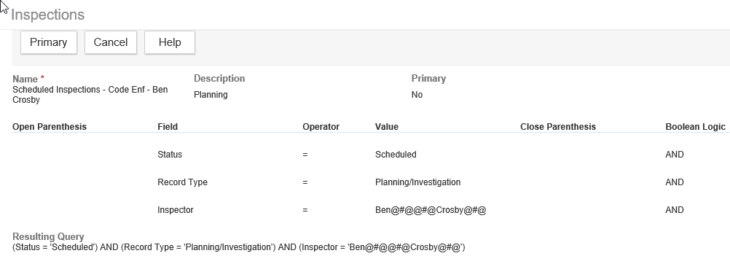

Active assigned planning reviews not in the planning module:
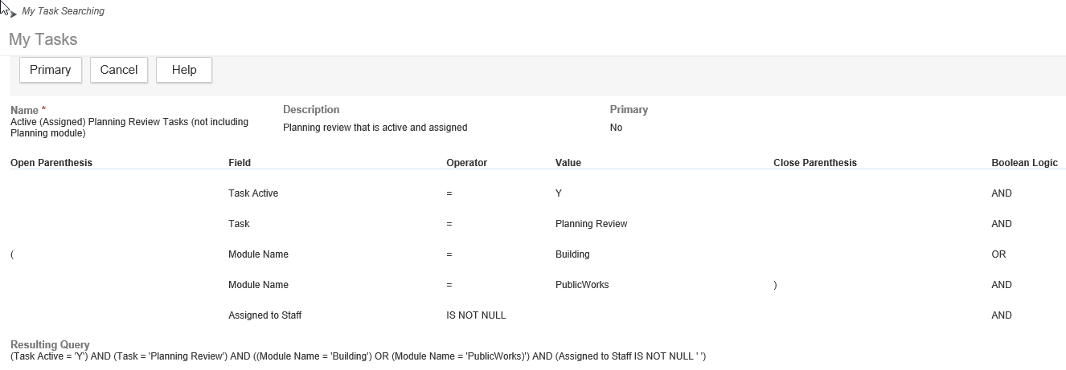

Base filter for Code Enforcement activity type:
