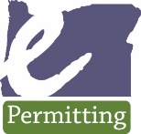 How to upload documents on ePermitting Accela Citizen Access (ACA)

- To browse to the permit/application to which you wish to upload documents to:
  - Mouse over the yellow SEARCH block at the top of the ePermitting home page [BuildingPermits.Oregon.gov]:
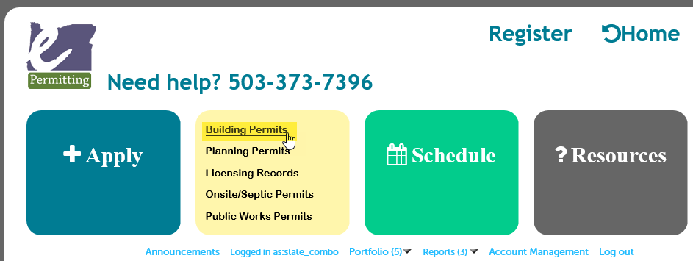
  - Search by entering the Permit/Application number or by partial address. Note: the best way to find information is to put less information into your search, so only enter the Permit/Application number with the dashes and leaving out any extensions like -MECH, -STR, -ELEC, -PLM, -PW, -PLNG - and when using the address search, use just the Street number and part of the Street Name. Any permits older then a year, please clear the Start Date so that it is blank to get all possible results:
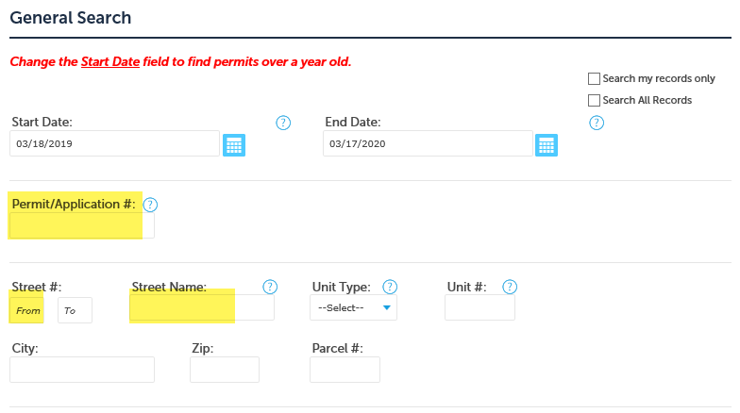
  - Select by clicking your record open from the list of resulting records. Note: if only one record matches your search, it will automatically open to that record – if more than one record matches your search, you will have to click the blue record number hyperlink to open the record.
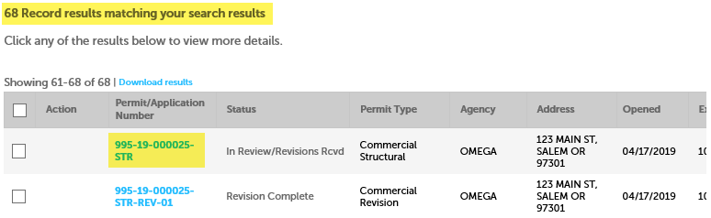
- Once your permit/application is loaded, go to Record Info/Schedule Inspections > select Documents Upload/View:
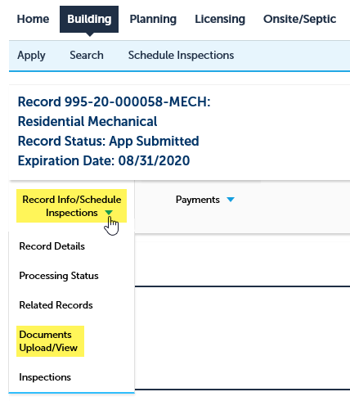
- IMPORTANT! Please note the limitations that are indicated for document upload in order to successfully upload your documents – file names, maximum size, and file types. Select the ADD button to start an upload.
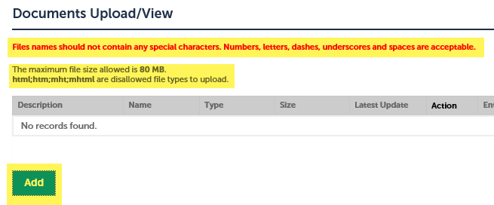
- A pop-up will appear, select the ADD button in this pop-up to locate your document – note, you can only load one single document file at a time – you will have to repeat this process to add each separate document:
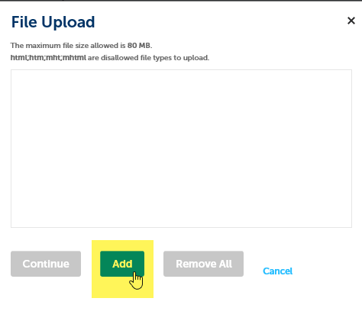
- Browse to and select your document > Open to select it. Note, you may not be able to see any network/shared drives you have setup on our local computer – you may only be able to see your local C:\ drive so consider copying/saving locally in order to upload your document. Once selected and opened, your document will show in the upload window pop-up as 100%, select Continue.
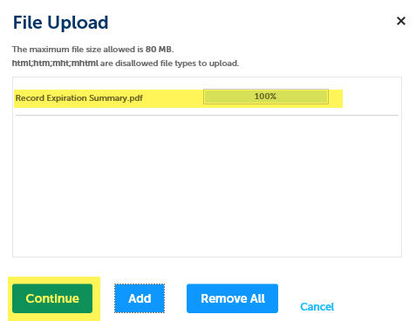
- You will be returned to the Document Upload screen on the web page – you must now fill in the required fields for Type and Description. The document Type defines how your document will be categorized/handled by the agency that holds your permit/application – you can only select ONE document type. The document Description is information only and can be very helpful in addition to the file name. Select SAVE to complete the upload.
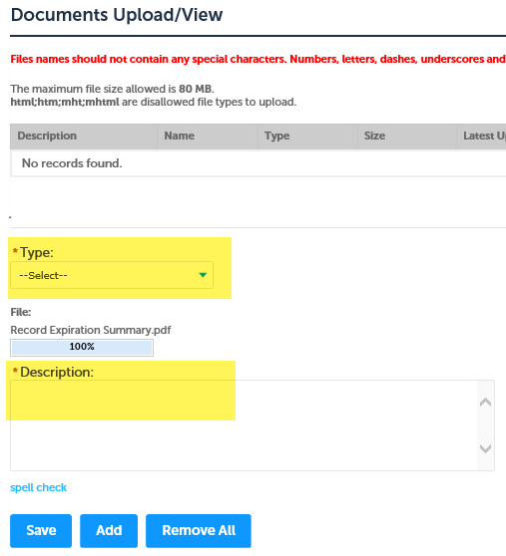
- The window will refresh and a ‘success’ message will be displayed – your document information will also be shown now as uploaded in the lower half of the screen:
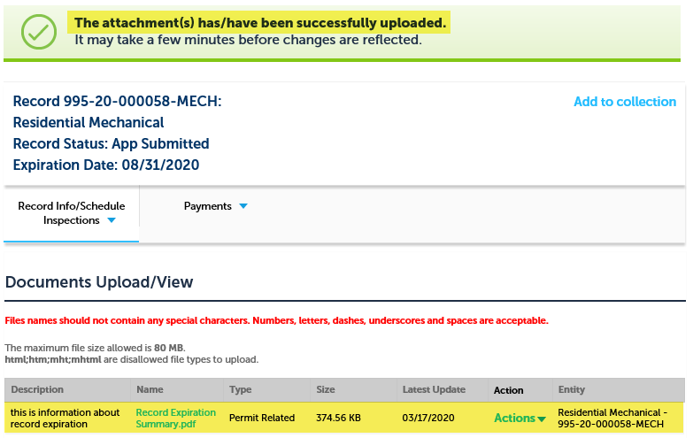
- There is an Actions dropdown > View Details that will display all the details for the document you have uploaded. There is also an active link to open the document itself. Please note, when viewing uploaded documents – the person viewing will have to have the source application for the file type you uploaded, i.e. if you uploaded a .doc file type, the viewer will have to have Microsoft Word to view the document – if you uploaded as .pdf, the viewer will only have to have a free reader to view the document – keep this in mind as you decide what file type to upload. Select ADD to upload another document and repeat this process.
