How to make Payments using SETS

3 Ways to Create a SET
- Through the Record List Search
- Through Related Records tab on a given record
- Through Intake (this is rarely used so will not be included in this training document)

Creating a SET thru the Record List Search
- Open the Record List page – Launchpad > Record List
- Select the Search button at the top of the Record List
- Input your search criteria – by Address or by Parcel are the most ideal ways to search record for SETS:
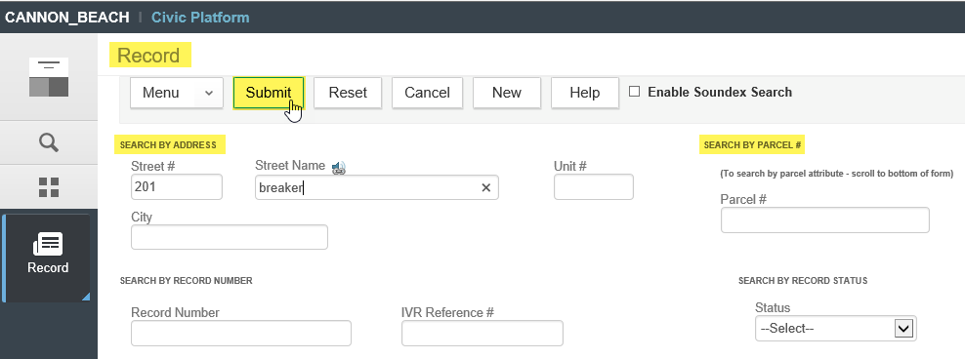
- Once the results of your search are returned, you can select all records or select just the records that you would like to include in the SET, then select the Create a Set dropdown:
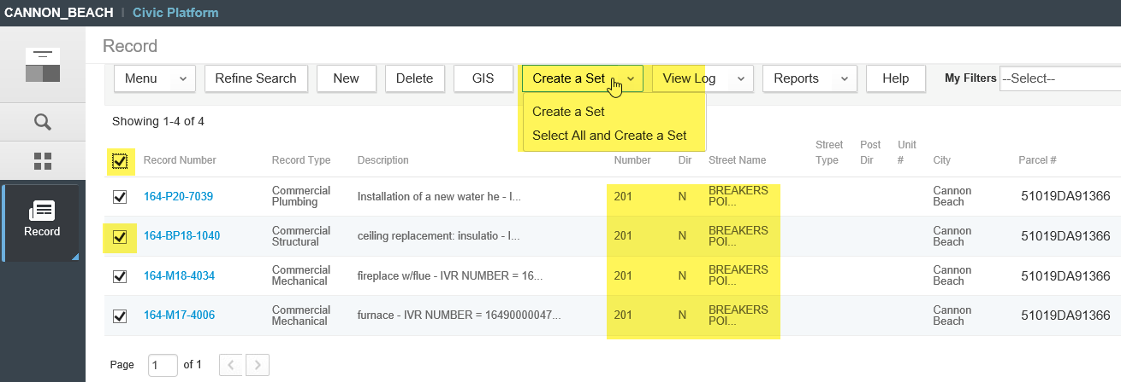
- The Create a Set screen will load – enter a SET ID, Set Name, and Set Type (always “Other” for payment purposes) – you can also include Comments, if desired: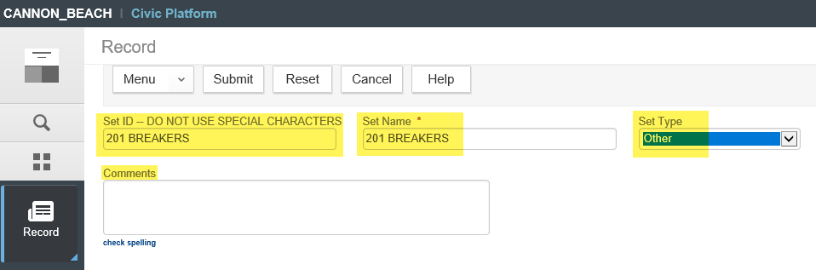
- Once the SET is created, go to the SETS page from your Launchpad. To favorite the SETS page – go to Launchpad > select All Pages > scroll to the Sets page and bubble in the start to favorite the page – this page will show now in your Launchpad group.
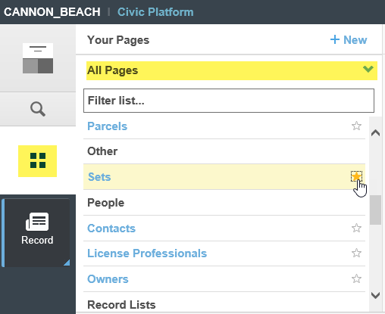
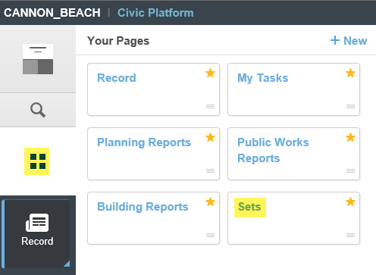
How to Create a SET from Related Records

- Browse to an individual record thru the Record List Search or Global Search – click the record to open it, navigate to the Related Record tab on the record. You can select all or some of the related records, click the Create a Set dropdown and create the set as per steps #4 and #5 above.
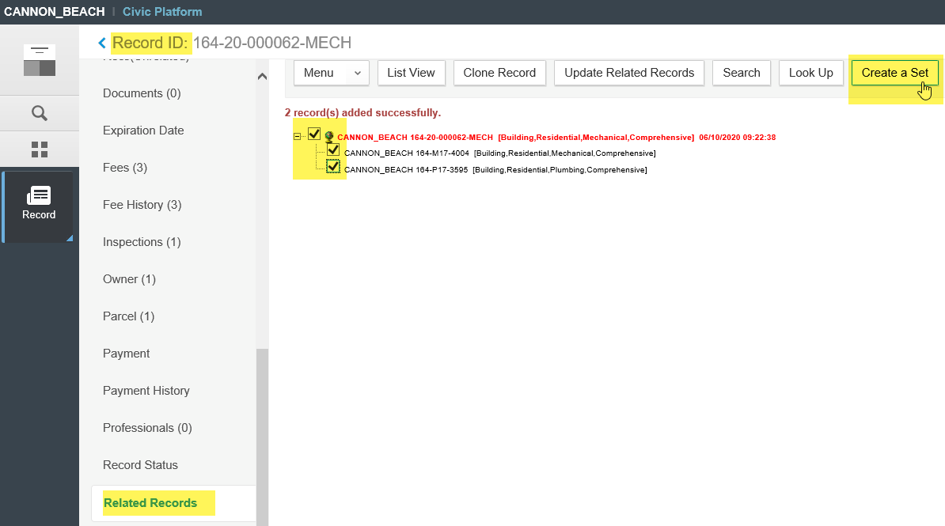

How to Process a Payment on a SET

- Open the SET page – Launchpad > SETS page. Locate your specific SET that you want to process a payment on. Click on the SET ID to open the SET:
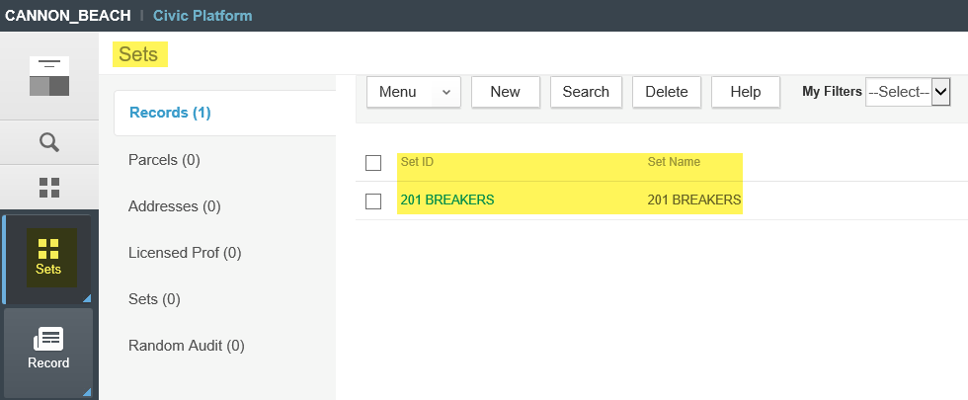
- Once the selected SET is open – there are several tabs available in the SET details (light gray navigation pane), navigate to the Payment tab to process a payment. Note, it is ideal that the fees have already been added and invoiced on the individual set records prior, so that an outstanding balance is ready and showing. If there is no outstanding balance showing in the SET – you can go to the Set Members tab, open the individual records, go to the Fee tab on each, ADD the necessary fees and invoice them for payment – all of this can be done from inside of the SET. Once there is an outstanding balance, return to the Payment tab in the SET details, and the TOTAL outstanding balance across all the included records will be displayed. Select the Pay button to initiate and process a payment on the SET – the payment is processed like any other payment in Accela.
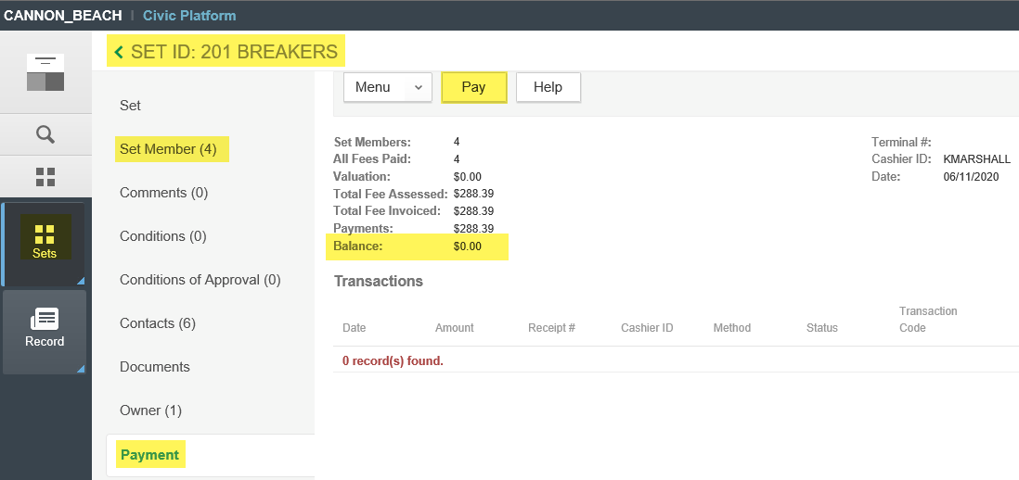
- The system will create a SET receipt that shows one payment paying all the included records. This pops up and can be emailed and/or printed as needed. You can also select the Set Members tab, click into each individual record, navigate to the Payment tab on each, and in the Transactions section of the payment window, select the individual Receipt Number link to generate the record-specific receipt as well.

How to Search for a SET

- Launchpad > Record List > select the Search button > enter SET criteria to search by:
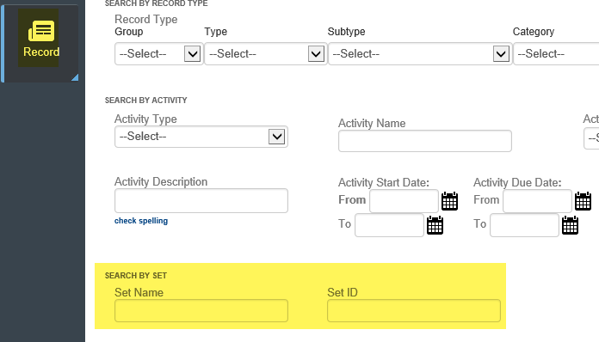
- Launchpad > SETS > select the Search button > enter SET criteria to search by:
