State of Oregon’s SelecTXT Solution

Schedule Inspections and Check Results Via Text Message
(888) 299-2821

The State of Oregon is proud to announce the launch of SelecTXT, a new service allowing contractors and homeowners to utilize interactive text messaging to:

- Schedule inspections
- Reschedule inspections
- Cancel inspections
- View inspection results
- Include comments/instructions for inspectors
How it works

With one word, users can begin the inspection scheduling process and SelecTXT will guide them from there. Helpful hints will ask them for an IVR tracking number and inspection code to complete the process in just a few key strokes. Users will have to do the following to:
Where’s my IVR tracking number?

IVR tracking numbers are generated by the State of Oregon’s permitting software and located on the customer’s permit document
Step 1:
Locate their IVR tracking number and inspection code

Step 2:
Text (888) 299-2821 with one of the following prompts

SCHEDULE or S to schedule an inspection

CANCEL or C to cancel an inspection

RESCHEDULE or RESCHED to reschedule an inspection

RESULTS or R to view inspection results

Step 3:
Follow the prompts

Looking for the inspection code list?

Text LIST to (888) 299-2821 to view the entire inspection list

OR VISIT
https://www.oregon.gov/BCD/epermitting/Documents/brochures/osm-inspection-codes.pdf
Is there a faster way? YES, with Express Commands

In addition to following the prompts, users can also use Express Commands to complete the process with a single text message. They simply need to include the inspection command, IVR tracking number, inspection code, and date request.

To SCHEDULE an inspection:
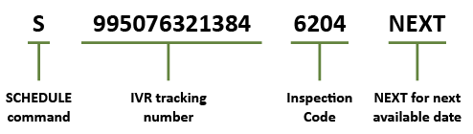

To RESCHEDULE an inspection:

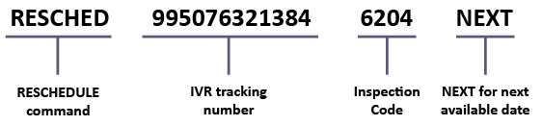

To CANCEL an inspection:

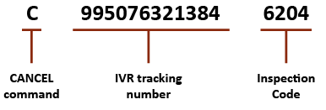

To view inspection RESULTS:

