Tips and Tricks

Presented at the 2019/20 ePermitting Regional Training & User Conference and is based on common training and Help Desk questions.
How to edit Workflow Task comments in Workflow History
Instead of using Supervisor in Workflow to edit the task comments, you can use the Workflow History to make the update.
- Select the Workflow History tab in the record navigation,
- Select the Task you wish to update by clicking on the blue task name,
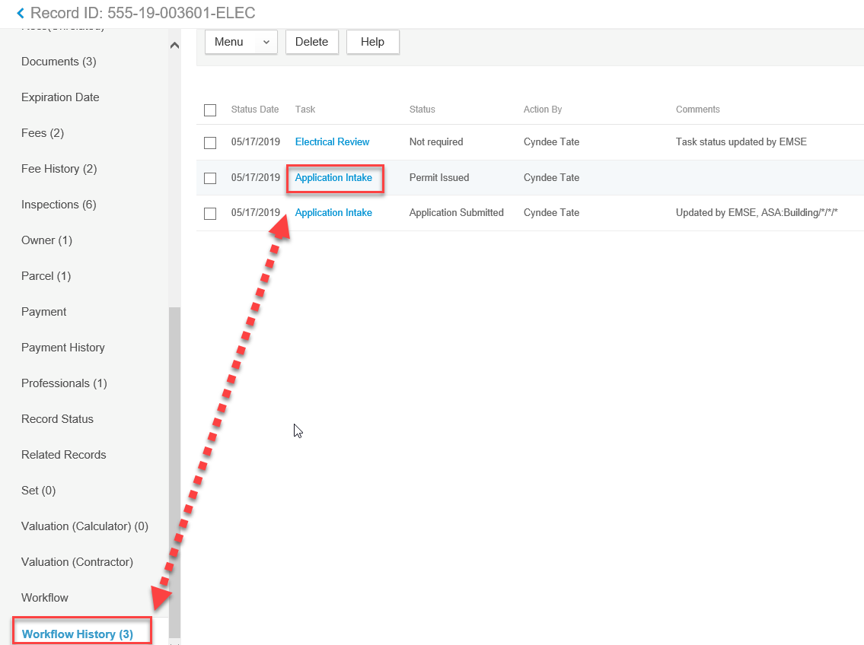
- In the Comments section update the comment as needed and when you have finished the update, select the Save Button at the top of the page. You cannot update Task Status at this point.
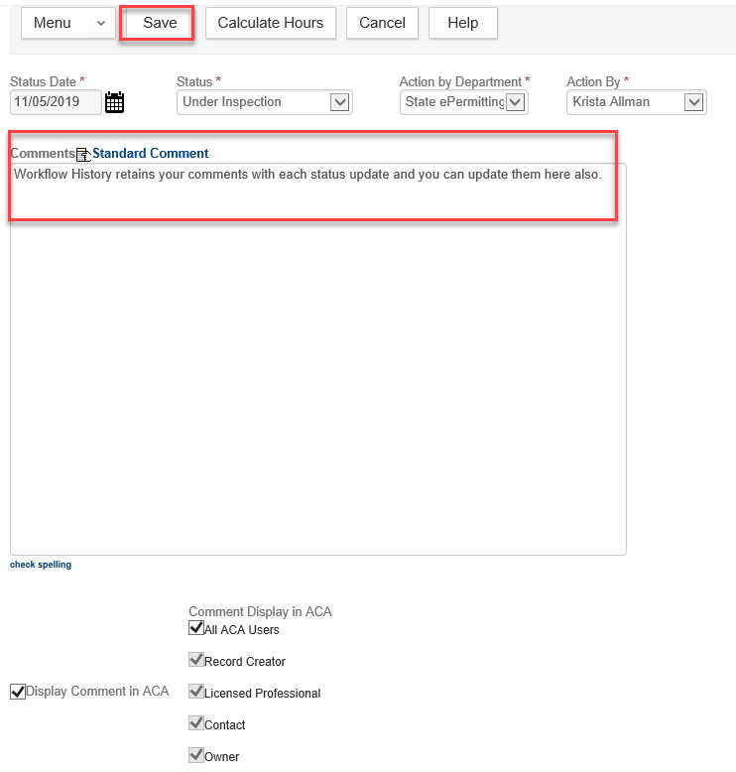

Quick assignment of Workflow Tasks through the Supervisor function
Instead of opening each review task in Workflow, you can supervise in to assign workflow tasks faster. *Note: To supervise in to Workflow, you will need user group permissions of Super Tech or Supervisor or higher.
- Go to Workflow tab in the record navigation,
- Select the ‘Supervisor’ button at the top of the page,
- Select the first review task that you want to assign,
- Here you can update the task to Task Active to Yes, Task Completed to No, Due Date and Assign Date to current date, and you can assign the task to a specific person by Department then User. Once the updates for this review task are complete, select the ‘Submit’ button at the top of the page to save your updates (saving will be required for each task you are updating/assigning),
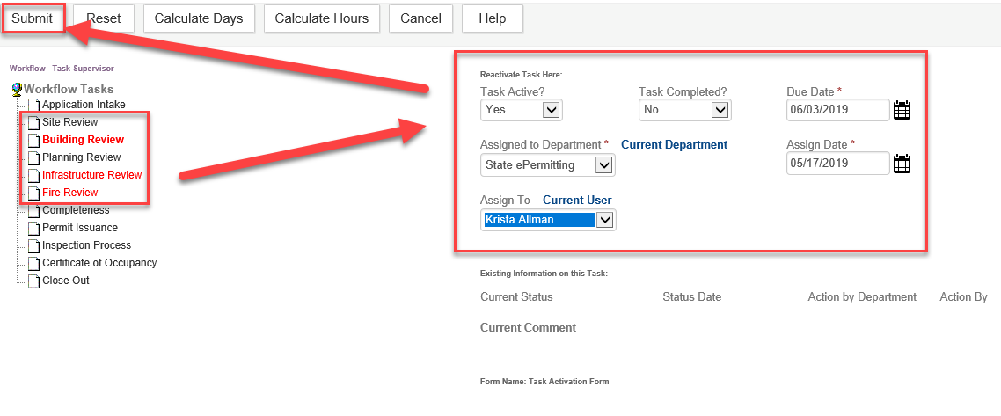
- Go to the next review task you need to assign and fill in the information as per the above, submit to save when the information is updated until you have assigned all review tasks,
- Select the ‘Cancel’ button at the top of the page to leave the Supervisor mode,
- You will now see that the Workflow Tasks view is updated with the correct assignments.
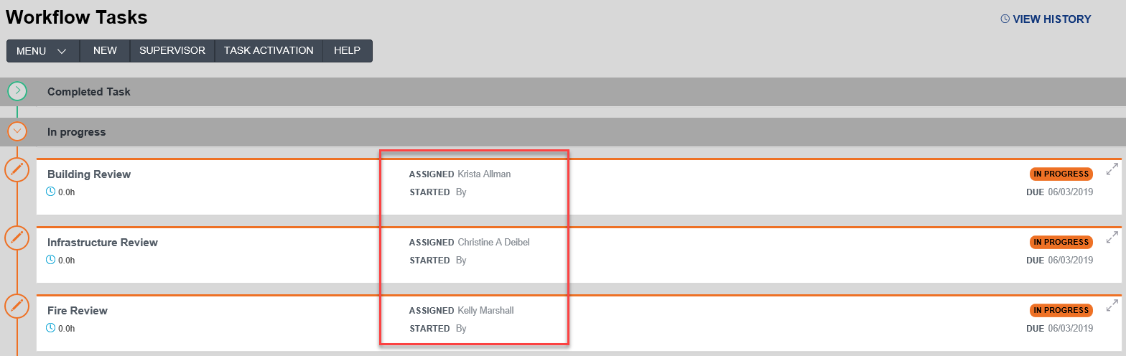

Custom Field/ASI Record List Search Option
Allows you to search all records based on a specific Custom Field (also known as ASI) and value, and the results are filtered on the Record list page.
- Open the Record list page and select the Search button at the top of the page,
- The ASI Search is broken out into sections allowing you to search by various data including Search by Custom Field Label and Search by Custom List Table. These are very powerful for the Public Works and Planning Tracking Modules particularly for “Application Type”.
- To use these two custom field (application specific information) search options – you must first be aware of the actual field label – this value is case sensitive and must be entered exactly as displayed in the record, as well as the value which is also case sensitive and literal. You can copy and paste these values from inside of a record if it is helpful. This type of search works best when the values are defined such as in a dropdown list field, ie. Custom Label = “Application Type” and Value = “Annual Permit” – this search allows you to pull up all the Annual Permits for Public Works.
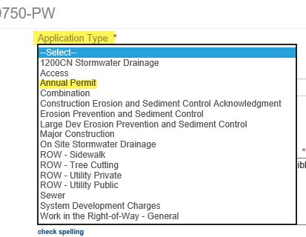
- Once you have filled in your search information click on “Submit” at the top of the page and the record page will now show your search results.
- After you are done using the search to filter the records you close the Record list space, go to Launchpad and reopen a fresh copy of the Record list.

Expired Record/Records about to Expire - Record List Search Option
In example 1 the Record Status of ‘Expired’ was selected to allow the system to search all records that are expired. In the second and third examples you will see all of the matching results.

Example 1: Applying the search filter, to search for records already expired - Record Status = Expired
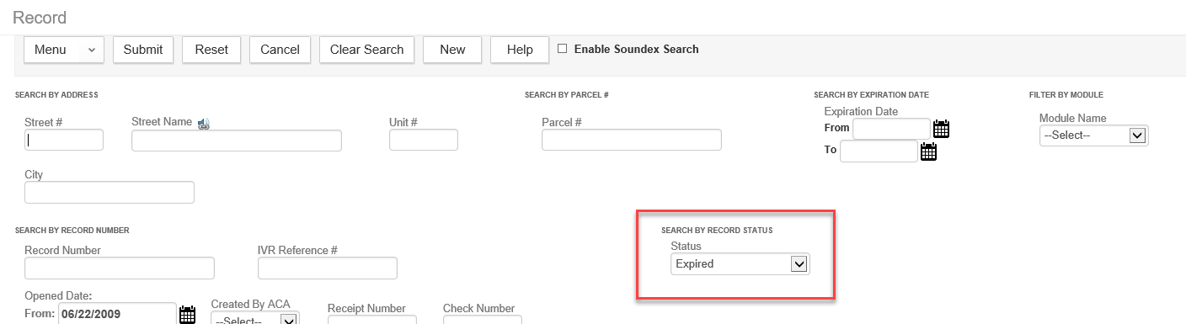

Example 2: Result after filter applied – you can then go to Menu > CSV Export to export this filtered list to Excel – and/or you can click the column header called “Expires” to sort the result list ascending/descending
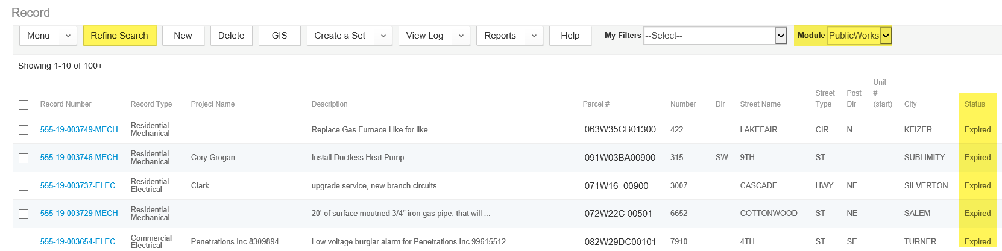

Example 3: You can also search by the expiration date, into the future – to see what records are about to expire – you could also restrict your results to a given module:
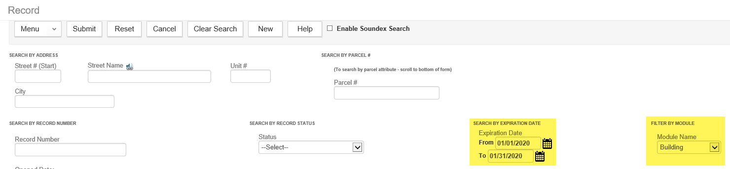

Example 4: Clearing the Search Filter by closing Record Space
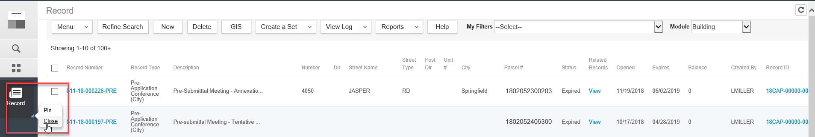

Example 5: Clearing the Search Filter by updating the search filter
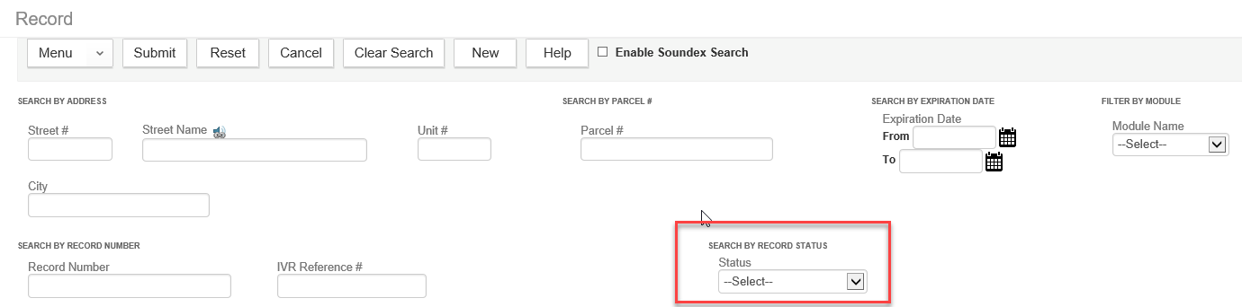

Building Information – as defined in the Oregon Standard Model (OSM)
This tip is in a separate document titled “Building Data in OSM”
- The document outlines the Type of work definitions
- Type of work business case examples
- Information about the Category of Construction
- Building Count information – for census, Dodge and McGraw Hill reporting

APO Information
- Consider the use of “temp” parcels and addresses – for things that will never receive a permanent parcel, named “temp” parcels can be very powerful and useful. And the more thoughtful you are about naming the “temp” parcels, the more useful they could be for reporting.
Ex. “temp” parcels called ROW – UTILITY, ROW – TRAFFIC, ROW – EVENT, etc. So not only would right-of-way ever be assigned a permanent parcel, where ROW would be the named “temp” parcel you would use – and further breaking it down more specifically would result in you being able to quantify how many right-of-way utilities you did versus traffic, and so on.
- When adding addresses manually to your reference APO, if you do not make sure to add the Address Type for your agency, the address will not be available online. There is a standard audit report for this if you think you may have addresses without Address Type. Remember, not every address should have Address Type, particularly “temp” addresses, so customers are not able to apply on this address online.
Licensed Professional Information
- When you associate an LP (Licensed Professional) to a record, you can edit the contact information for that LP at the record level – such as phone number or email. It is never recommended however that you edit LP information in Reference Professionals, as anything you edit will be overwritten the next time ePermitting does a new load [nightly for CCB and BCD Professional license types; monthly for all other license types). Ultimately, if the LP information is not correct at the time you associate it to a record, the Licensed Professional should be referred to the licensing body with which they hold their license to make the necessary corrections. ePermitting is only loading license information provided by other agencies, they are responsible for maintaining it.
- If the reference license contact information is correct, but is not the local office or person(s) you are working with – then you would create a NEW Reference Contact for that contact to also associate to incoming records as needed.
- Go to Kayako Knowledgebase to review People Reference documentation in the Reference Category.
SelecTXT – tool for scheduling inspections via text message
- No app required!
- Very easy and quick, is saved to your phone text for reference
- The scheduling phone will receive an automatic result notification once the inspection is resulted
- Can completely schedule an inspection in one text message

