Displaying Task Activation Screen – Work Around

There is a known issue with the Task Activation screen (where parallel tasks are selected) where it will intermittently close without allowing the user to select the tasks. There is a work around available until Accela resolves the issue.

- In Workflow, user may selects Ready for Plan Review status, for example.
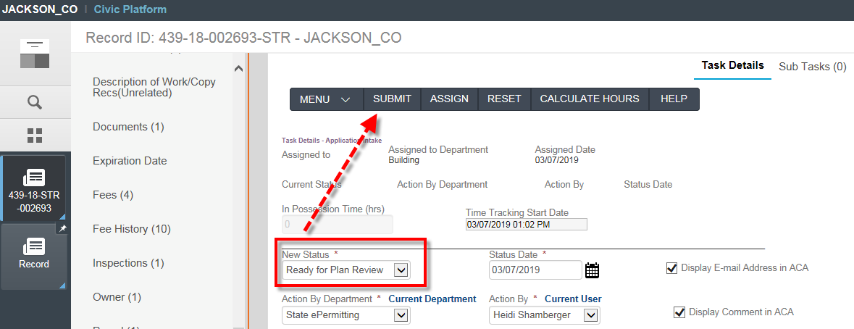

- The Task Activation screen will display momentarily but immediately flashes and closes so tasks cannot be selected and all tasks end up being active in workflow.
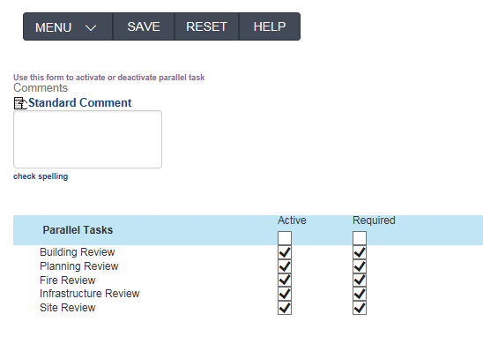

- If this occurs, you can work around this issue. Go to Workflow > click on Task Activation.
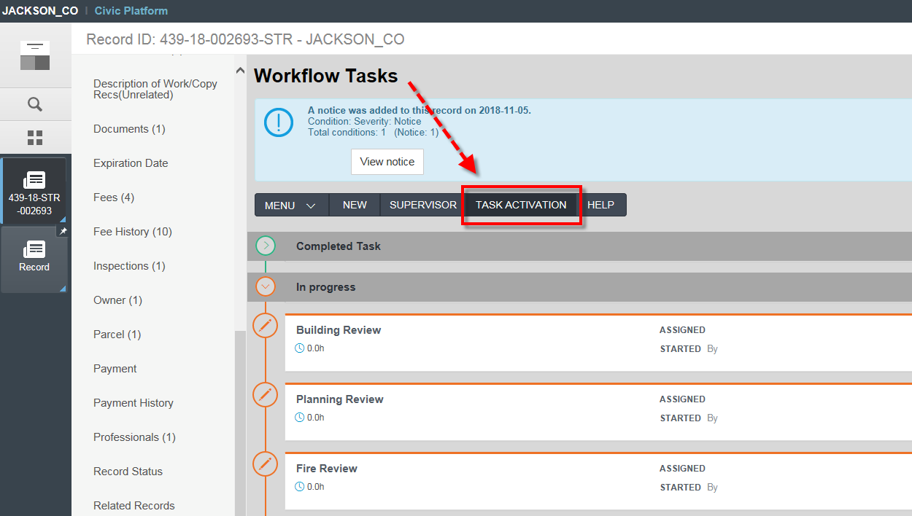

- The Task Activation screen will appear. Click on any of the RED parallel tasks. This will show the Parallel tasks on the right side to select. Click Save. Finally, click Cancel to exit this screen.
